Watermark Pattern & Pen

- File > New > Custom > 300 Pixels x 300 Pixels > Background Contents: White
- File > Reference Image (This layer will be deleted at the end of the project!!)

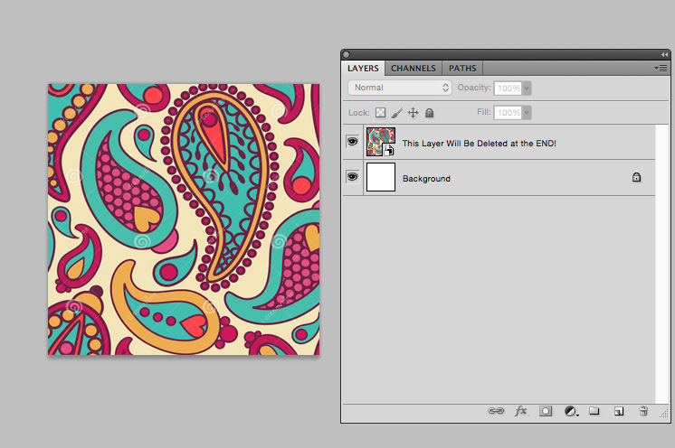

- Layer > New Layer (To apply strokes, color, and detail.)
- Use the Pen Tool (Select “Paths” in the Options Bar.) and create two intricate designs with a specific color scheme. Create a New Path for each shape.

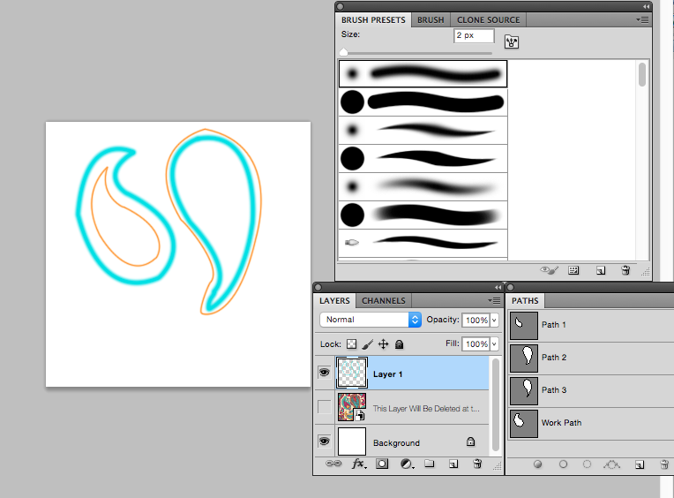

- Move your designs into the center of the document. Pay close attention to the space on all four sides, it should be equal.
- Edit > Define Pattern > Name > OK

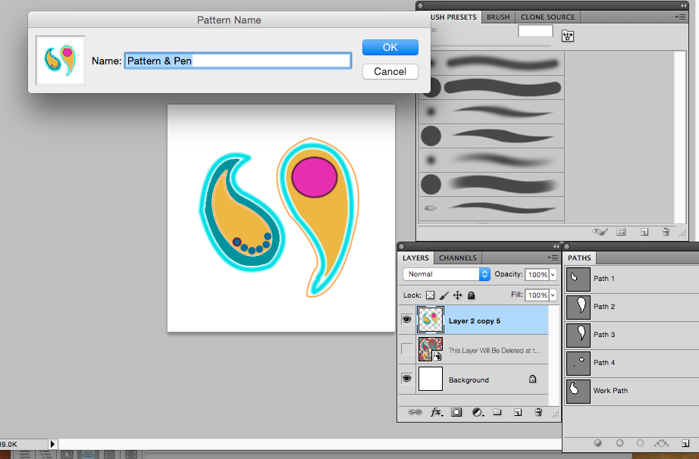

- File > New > U.S. Paper > Background Contents: White
- Paint Bucket Tool > Pattern > Select the pattern you created.

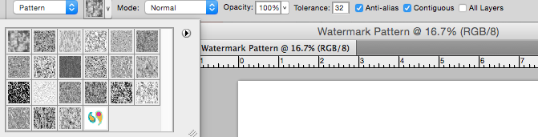

- Create a blank white layer at the bottom of your layers panel.
- Change the opacity of your pattern to create a watermark.

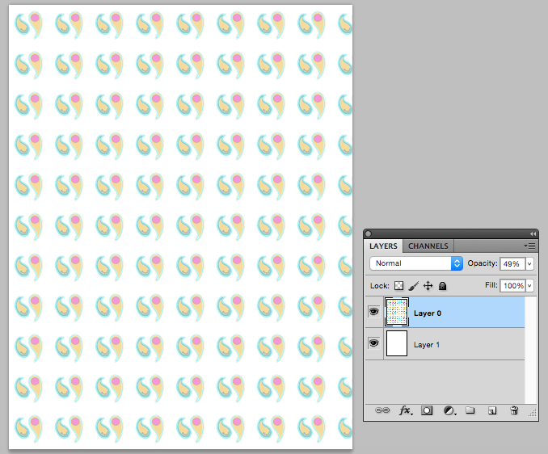

- Submit both files to the Drop Box. Your file containing work with the Pen Tool and the file where you created your watermark pattern.

