Watercolor
In this tutorial we will use Photoshop and some brushes from www.brusheezy.com

Step 1
Open Photoshop and create a new document (US Paper).

Step 2
Add a new layer (Layer > New > Layer) and fill it with white (Edit > Fill > White). Make sure you have black and white for the foreground and background colors, these are your default colors.
Then go to Filter>Texture>Texturizer. Use Canvas for the Texture, 75% for the Scaling, 3 for the Relief and for the Light choose Top Right.
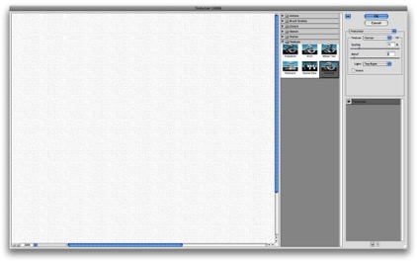

Step 3
Add the parchment paper. It is in Computer Graphics – Watercolor – Parchment Paper.
Place the image in the document on top of the other layers. Adjust the size to fit the canvas (Edit > Free Transform). In your Layers Palette, hold down Shift and select your Texture Layer and Parchment Paper Layer and Layer > Merge Layers. Finally, change the Opacity to 50%.

Step 4
Now place an image in our document and size to fit. The image has to go on top of the parchment paper layer. With your image selected in the Layers Palette go to Layer > Group Layers. The layer of the image will be inside a folder in the Layers Palette. Select the folder and go to Layer>Layer Mask>Hide All.
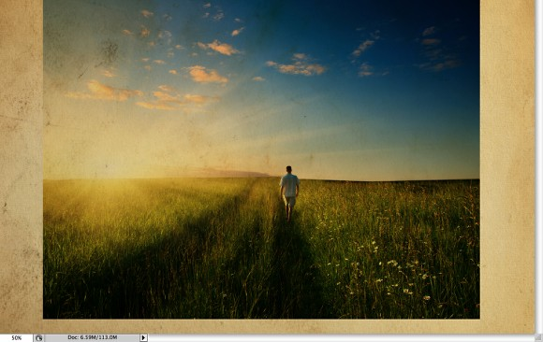

Step 5
The image is hiding because of the mask. So now, let's use some Watercolor Brushes. The ones I use are from Brusheezy and you can download them here http://www.brusheezy.com/brushes?search=watercolor.
Search “Watercolor” and download any free watercolor brushes. Open your downloads and pull Watercolor Brushes.abr to your PS icon. Window > Brush Presets (they should be at the bottom).
So select one of the watercolor brushes and use white for the color and paint on the layer mask of the group. You will notice that the image will start showing.
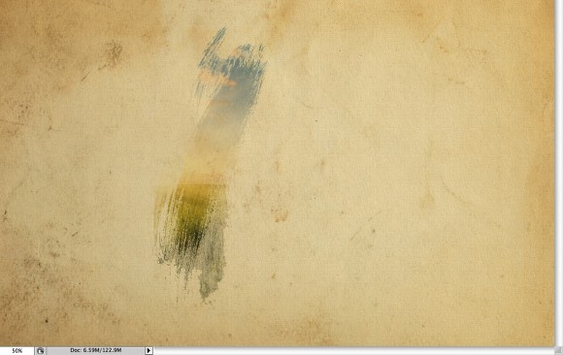

Step 6
Pick another Brush and paint again.
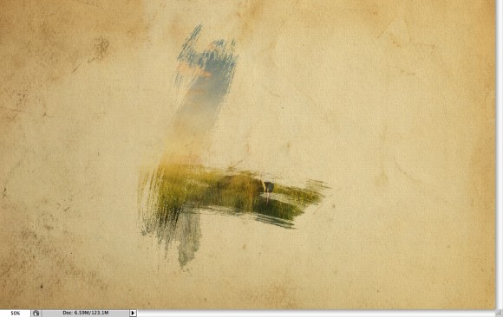

Step 7
Keep painting until you can see the image without losing the brush splatters.
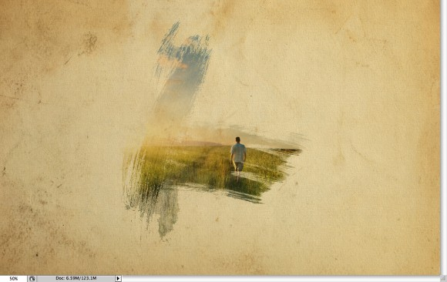

Step 8
Now add another layer, this time beneath the Folder that the image is in. Then again using the watercolor brushes paint over the layer using colors that enhance your image. Use the image below for reference.
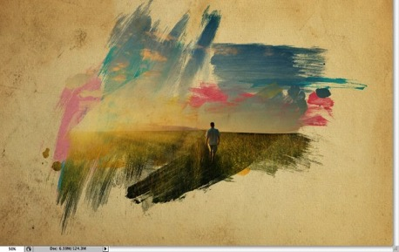

Step 9
Select your image in the Layers Palette. Layer > Rasterize > Smart Object. Now your image is ready to be adjusted.
Let's just adjust the color of the image. Select the image and go to Image>Adjustment>Photo Filter. Select Warming Filter (85) and 55% for the Density. Also select the Preserve Luminosity option
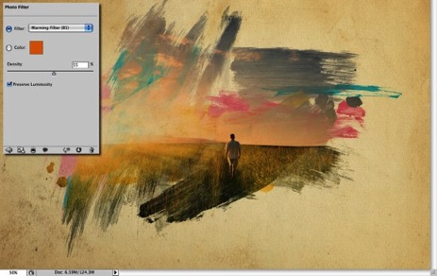

Step 10
Select the image and go to Filter>Artistic>Dry Brush. Use 0 for the Brush Size, 9 for the Brush Detail and 1 for the Texture.
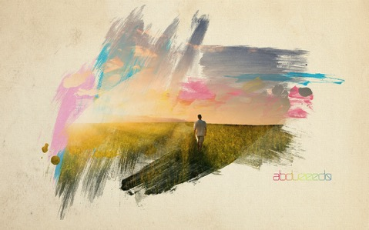
Do not Flatten. File > Save As “your name watercolor”. Submit to the Drop Box.

