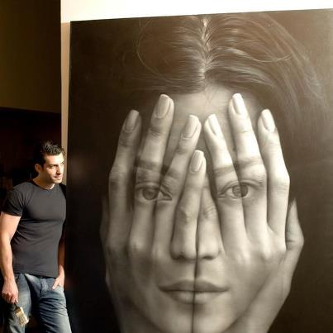

Tigran Tsitogdzyan

- Take 4-5 photos of yourself with Photo Booth.

- Decide which two you will use to “blend together” and arrange them side-by-side.

- Select and move a feature from one image to the other.

- Use a soft Eraser to clean up the edge.

- Arrange features around your image and change the Opacity within the Layers Panel. Also, use Adjustments to alter contrast and brightness.

- Change the color of your image to Sepia. You may use the Color Replacement Tool (Foreground Color = Light Brown).

- Merge additional images into your design.

- YOU NEED TO SUBMIT 2 DIFFERENT DESIGNS (JPEG Format only)

- MAKE YOURS UNIQUE. HOW CAN YOUR ARRANGEMENT BE DIFFERENT? THINK ABOUT EMPHASIS, UNITY, CONTRAST, RHYTHM AND OTHER PRINCIPLES OF DESIGN.

