Surrealism
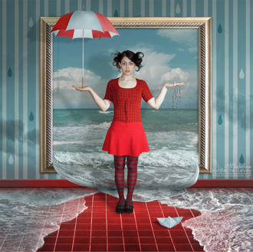

Final project must include:

- Background
- 5 different images selected using the Refine Edge.
- Characteristics found in Surrealist artwork. Dreams, nightmares, illusions, mutations, and juxtaposition.
- Techniques developed with Photoshop. Merge images together, opacity, change color, change lighting, filters, copy images, and creating masks.
- Shadows
- Brush / Blur / Smudge
- Burn / Dodge

