Sketch to Vector Image
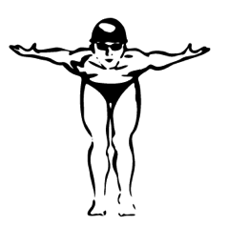
PS –
- File > Open sketch
- If you need to rotate – Image > Image Rotation
- Image > Mode > Grayscale
- Image > Adjustments > Levels
- Transparent Background with Channels Panel
(Quick Recap – Command A, Command C, New Layer, New Channel, Command V on Alpha 1,
Load Selection from Alpha 1 with Invert, Fill with Black, and Delete Background Layer)
- Add line variation with Brush Tool, Pen Tool or Select > Color Range (Fill with Black)
- Save As > PSD

AI –
- File > New (800X600 Pixels and RGB Color Mode)
- File > Place your PSD file
- Window > Link if you need to make changes to your original PSD
- Window > Image Trace
    - Preset: Sketched Art (Cancel initial Trace)
    - Ignore White
    - Mode (Black & White)
    - Trace > OK

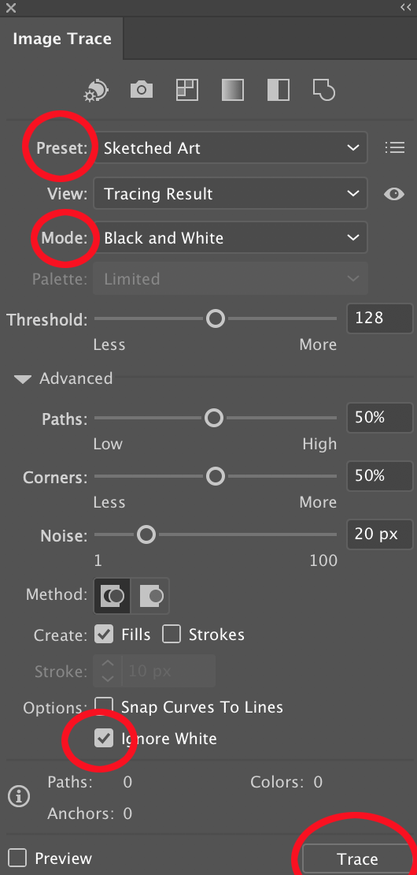

- Object > Image Trace > Expand
- Object > Ungroup
- Edit > Edit Colors > Convert to RGB

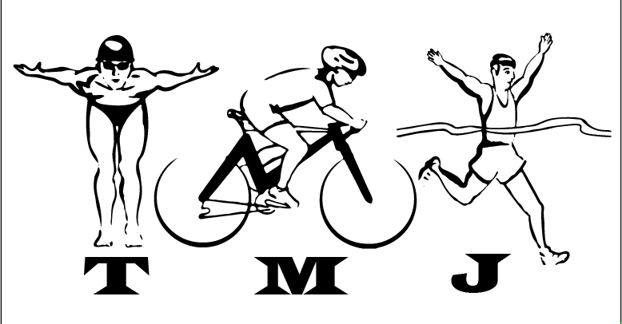

As you keep experimenting in Illustrator you may decide to try:

Object > Arrange
Object > Compound Paths

