Sketch to Vector Image
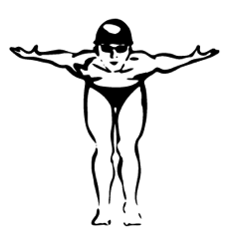
PS –
- File > Open sketch
- If you need to rotate – Image > Image Rotation
- Image > Mode > Grayscale
- Image > Adjustments > Levels
- Paint in outlines and areas to enhance. Use Pen Tool or Select > Color Range (Fill with Black)
- Transparent Background
- Save As > PSD

AI –
- File > New (800X600 and RGB)
- File > Place your PSD file
- Object > Live Trace > Tracing Options
    - Preview
    - Ignore White
    - Mode (Black & White)
    - Raster = No Image
    - Vector = Tracing Results
    - Check Fills
    - Save as a Preset

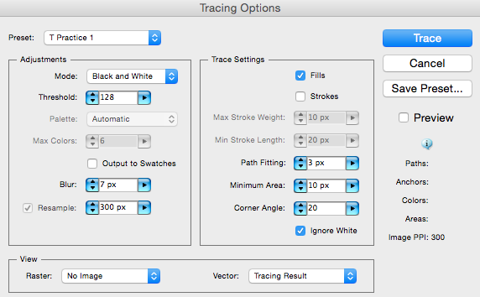
- Link if you need to make changes to your original PSD
- Object > Live Trace > Expand
- Object > Ungroup

