How to Create Reverse Saturated Graphics

Reverse images, or white text or imagery on dark backgrounds, has become quite popular, especially with the recent chalkboard graphics craze.

This technique works best when you start with pure black and white images. I’ve found line drawings and Victorian etchings like the one below work particularly well.

- Drag your image into Photoshop. Using the Magic Wand Tool (Make sure Contiguous is NOT selected) select the white space on your image. Now Select > Inverse to reverse your selection to select just the black portions of the design.

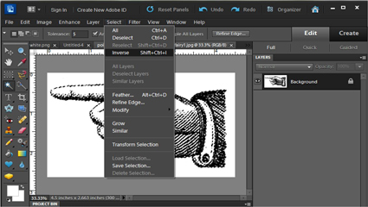

- Now you want to copy just that portion and put it into a new file. Edit > Copy.

- Create a new blank document by going to File > New. Clipboard size, choose the number of pixels – 72 is good for web-viewing; I choose 300 pixels if I’m going to print it out. Make sure the Background Contents section says Transparent. Click OK.

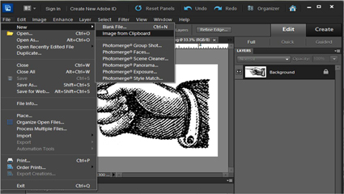

- You should now have a new empty image sized and ready to receive your copied image that’s still on the program’s clipboard. Edit > Paste to paste in your image to the transparent background.

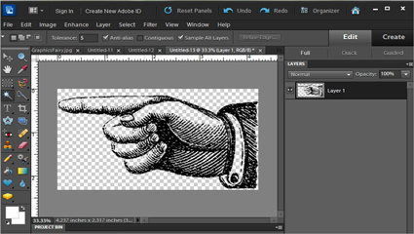

- Click the half black and half white circle in the layers palette and select Hue / Saturation. Move the lightness slider over to +100 to turn your image from black to white.

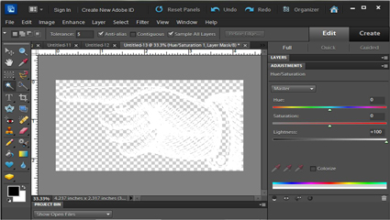

- Now save your graphic as a .png file to preserve the transparent background. You need the transparent background so you can layer your graphic over colored backgrounds, other images, and textures.

