QuickTime Player Recordings

- Click and HOLD QuickTime Icon > New Screen Recording
- Click the red button to start recording 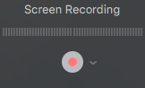

- Click to record full screen or drag to record a selection of your screen.

- Click the button at the top of your screen to end recording

- File > Save your recording to your Desktop

- Open iMovie > File > New Movie

- Drag your QuickTime file from your Desktop into iMovie

- Change speed to FAST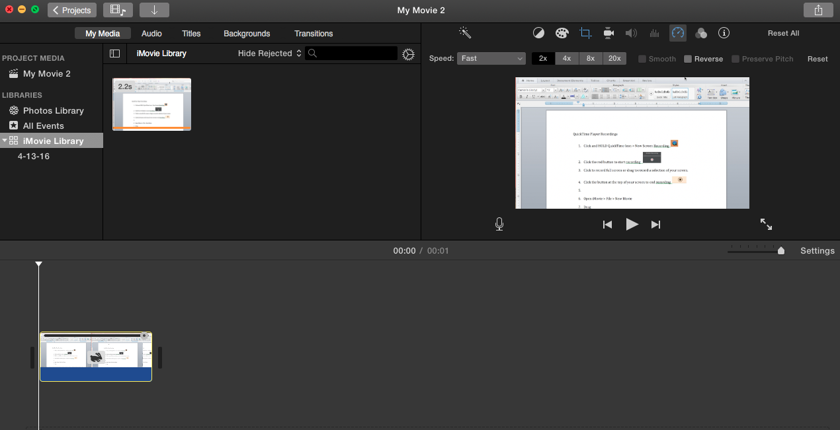

- Save File to Desktop 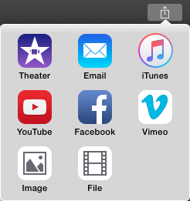

- Your recording should now be saved as an .mp4

