Pushing Color
Using the Liquify filter gives more dimension, texture, and depth to your digital painting.

- File > Open a photograph of a flower. Simply the flower:
Image > Adjustments > Desaturate
Layer > Duplicate Layer
Image > Adjustments > Invert
Change Blending Mode from Normal to Color Dodge
Filter > Other > Minimum > 2 Px
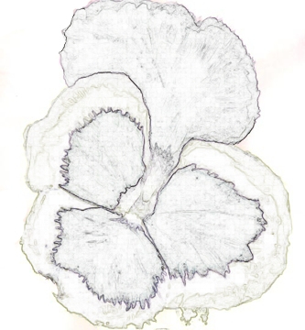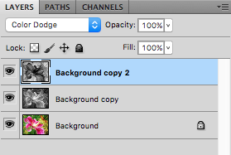
2. Layer > New > Layer and Select the brush and colors you want to use for your painting. For colors, I chose a soft pink hue for the background, deep violet purple, lavender, and bright purple for the center of the flower that I simply created long brush lines without worrying too much about where the color was bleeding. Then, I used three shades of yellow from soft to bright for the outer edge. I added a white and pink edged tip for the petal on the left. I also feathered the edges of the purple center of the petals for a natural appearance.
3. I added a few muted shades of plum in with the soft pink at the bottom right corner. I also added soft yellow tip to the largest petal.
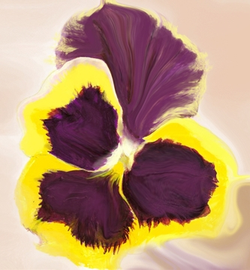
4. Next use the Liquify filter, select Filter > Liquify. For the first filter, I use the warp tool and push the color from the outside into the center to create distinct movement and lines.
Here’s a quick look at the tools available in Liquify:
- Forward Warp Tool Pushes pixels forward as you drag.
- Reconstruct Tool Fully or partially reverses the changes you’ve made.
- Twirl Clockwise Tool Rotates pixels clockwise as you hold down the mouse button or drag.
- Pucker Tool Moves pixels toward the center of the brush area as you hold down the mouse button or drag.
- Bloat Tool Moves pixels away from the center of the brush area as you hold down the mouse button or drag.
- Push Tool Moves pixels perpendicularly to the stroke direction. Drag to move pixels to the left, and Alt-drag to move pixels to the right.
- Mirror Tool Copies pixels to the brush area. Drag to reflect the area perpendicular to the direction of the stroke (to the left of or below the stroke). Alt-drag to reflect the area in the direction opposite to that of the stroke (for example, the area above a downward stroke). Use overlapping strokes to create an effect similar to a reflection in water.
- Turbulence Tool Smoothly scrambles pixels and creates fire, clouds, waves, and similar effects. To adjust the smoothness, drag the Turbulent Jitter pop-up slider in the Tool Options section, or enter a value between 1 and 100 in the text box. Higher values increase smoothness.
Use All 8 tools!!!
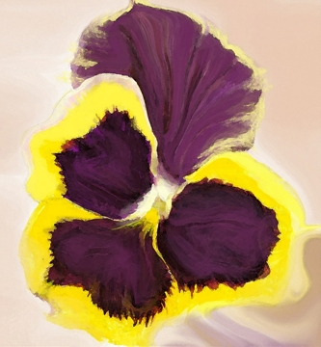
5. I select Filter and then choose “Artistic” and “Watercolor” to add depth. (You may not see the difference until you do it in your own painting or download this image and enlarge it to see the texture added.
6. I added various shades of green brush strokes around the upper right corner. I added deeper orange color near the tip of a couple of the petals. Next, I selected “Filter” and “Liquify” again using the clockwise tool to create an interesting center, pushed more color in different directions within the flower.
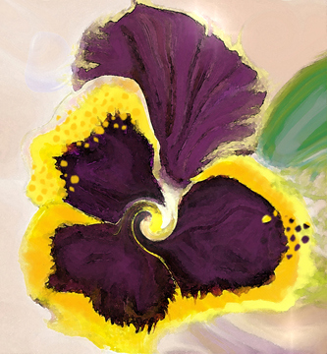
7. To complete this simple painting for the tutorial I added dots, a raindrop element in the far left and the smudge tool to soften some of the edges.
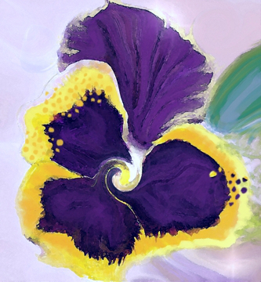
8. Same final painting — however, changed the “Hue” to darken the color to show more blue purple instead of violet. I show this so you can see that you can alter an image just by working with “Adjustments”.

