Pop Art

PART 2. Adding color to part 1.

1. Creating Fill Layers
Duplicate the “dots” layer.
Rename this layer “white” and drag it below the “dots” layer in your layer palette.
Adjust the Levels on the “white” layer.
Image >> Adjustments >> Levels
In the output levels, click and drag the black marker all the way to the right so it is behind the white marker (see image below)
Now the “white” layer is white!
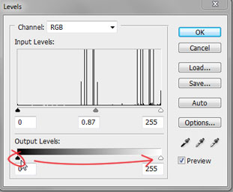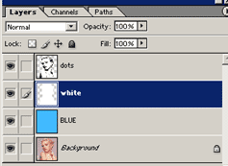
Change the blend mode on the “dots” layer to Multiply.
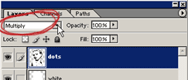

When you begin to repeat more Fill layers START HERE!!
2. Select your white layer and click on this icon at the bottom of your Layer Palette and select Solid Color.
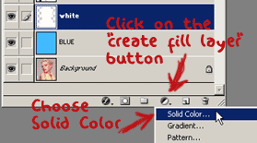
Select a color in the Color Picker dialogue box. Click OK. I’ve gone for a red shade to color her lips. You don’t need to be too picky here because we can change the color easily later on.
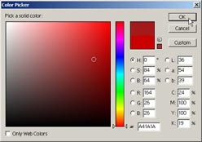
3. The new fill layer created will appear in your layer window.
Right-click and rename the layer. This example renamed the red fill layer “lips” to color the lips.
Drag the new fill layer below the “dots” layer in your layer palette. Your image is now totally filled with the color of the fill layer…but don’t worry we are about to fix that.
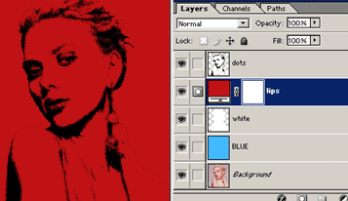
Create a Clipping Mask between the “lip” and “white” layer. This will ensure that you don’t color over the lines. To create a Clipping Mask go to Layer > Create Clipping Mask.

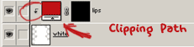

Change the foreground color to black. Working on this new layer, take your Paint Bucket Tool and fill the “lips” layer black by clicking anywhere on your image. The color disappear, this is because the color will only show up where there is white on this fill layer.

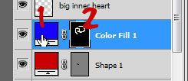
4. To change the color of this layer you will double click on the “layer thumbnail” marked with a 1 in the image above. To change where this color appears on your canvas, click on the “layer mask thumbnail” marked with a 2 in the image above. Then using white with your Brush tool, paint on your canvas where the color is to appear and paint with black to erase the color.

(Error message: “The fill for this layer must be rasterized before proceeding. It will no longer be editable as a fill. Rasterize the fill?” If this message appears, you’ve made a mistake. Select “No” and click on the “layer mask thumbnail” in your active layer before editing this layer.)

Now for the coloring. Change the foreground color to white. Get your Paint Brush Tool and start painting where you want to the color to appear. Use a hard brush with the opacity set to 100%. Make sure that you zoom in when coloring, so that it is nice and tidy!
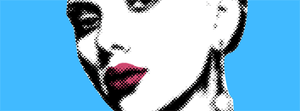

5. More Fill Layers
Repeat the above steps, starting at Step 2, creating a new fill layer for each color/item in your picture.
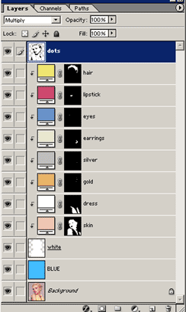
Note how I have used clipping paths on all the new fill layers.
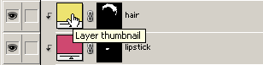
At any time if you are unhappy with a color that you have chosen, simply double click on the Layer Thumbnail (as shown above) and re-select a color. Now you have the ability to change the color of the hair for example, to a whole new color in a second flat!!
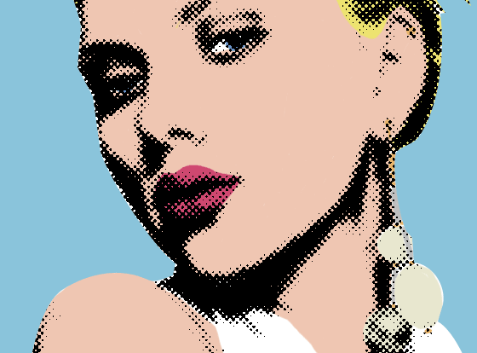
You may want to add a caption, or a speech or thought bubble to make this a Lichtenstein inspired piece.
Custom shapes have a few speech and thought bubbles to choose from.
Save and Submit.

