Pop Art

PART 1. Creating the Half Tone Shading
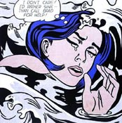
- Drag your image into a new document (US Paper).

Delete white background layer (Double click layer to unlock first).
Create a duplicate layer of your image layer (Layer > Duplicate Layer).
Rename this new layer “dots”.
Create another new layer and fill it bright blue using the Paint Bucket tool .
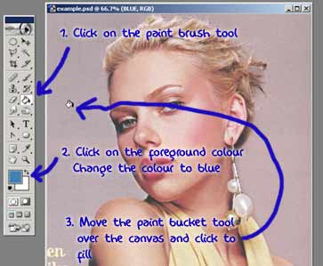
2. Drag this layer between the two existing layers and rename it “blue”.
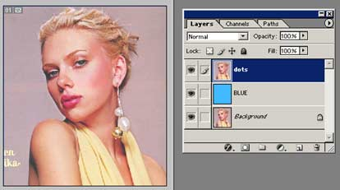
Now working on the “dots” layer we need to clear out all the unwanted parts of the photograph. In this case I want to isolate Scarlett and delete the lilac background.
To cut out Scarlett I can use the Pen Tool.
Remember to make sure the pen tool is set to create a Work Path.
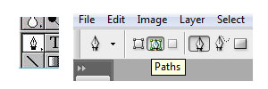

- Use the Pen Tool to create a path around the person (or thing) and then make it into selection.
To make it a selection, click the circle at the bottom of Paths that looks like a selection.
Invert the selection : SELECT > INVERSE and hit delete.
Deselect (Ctrl + D)
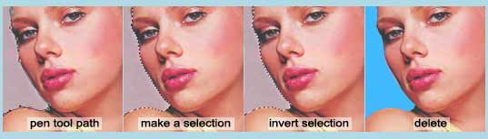

4. Making the Dots
Desaturate the “dots” layer (Shift + Command + U).
Next adjust Threshold to something dramatic (still working on the “dots” layer).
Image >> Adjustments >> Threshold…
The settings I used are shown in the image below, but you will need to experiment to see what threshold settings works for YOUR image.
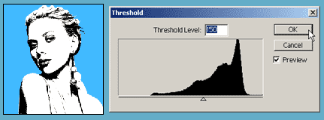
- Using Threshold will leave the image looking very pixelated (jagged). So apply Gaussian Blur (approximately a 2-3 pixels should do it).
Filter >> Blur >> Gaussian Blur…
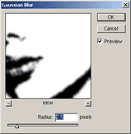
In your Layers Palette right-click on the “dots” layer and select Duplicate Layer.
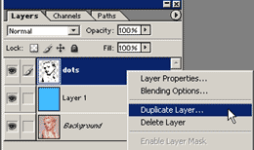
Select New for the Destination Document. Now you will have 2 documents open in Photoshop.
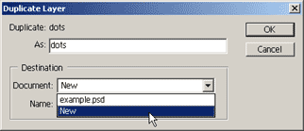
6. Working on your new document change the Mode to Greyscale.
Image >> Mode >> Greyscale
A dialogue box appears…”Discard color information?”…Click OK.
Now change the Mode to Bitmap.
Image >> Mode >> Bitmap
A dialogue box appears…”Flatten layers?”…Click OK.
Choose Halftone Screen on the Bitmap options window.
Make sure your output resolution is the same as the input. If your input doesn’t equal your output you’ll end up with a change in size! Click OK.
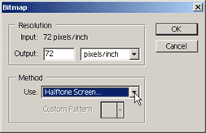
Next appears the Halftone Screen box. Apply the settings shown below. Note you may want to experiment with the Frequency as this decides the size of the dots. Click OK.
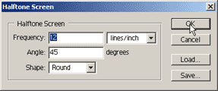

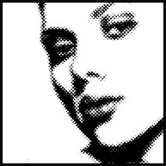
Note if your dots aren’t looking very good you may have forgotten to apply blur or need to apply more blur. The smoother gradient is, the better halftone pattern.

7. Organizing
Change the Mode back to Greyscale
A dialogue box will appear. Make sure the size ratio is 1 and click OK.
Now change the Mode back to RGB.
In your Layers Palette right-click on the layer and select Duplicate Layer.
There should be 3 three options as the Destination Document. Choose your original psd (which should be the top one).
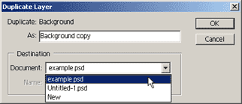

Your Layers Palette should look like the one shown below. You can close the second psd that you created..there’s no need for it now.
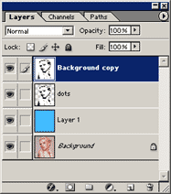
8. The final step for creating the dots is to create a Clipping Path between the new layer and the “dots” layer.
To create a Clipping Path hold down the ALT key and move your cursor between the 2 layers in your Layers Palette. When the cursor turns into a “double bubble” (see image below) click to create the clipping path.
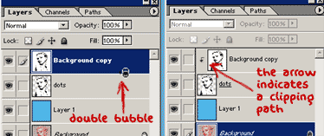
Now merge the “dots” and “Background copy” layer. Click on the “background copy” layer in your layer palette and then Layer > Merge Down.

Your picture should now look like the one shown below.
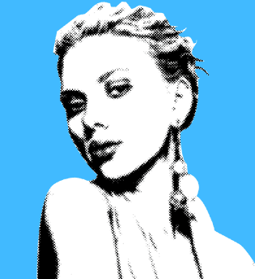
Save your work.

