PHOTO STRIP - FINAL

1. Create a Strip (Vector Shapes)
First, create a strip with the Pen tool. Use this shape as a guideline and for masking purposes.
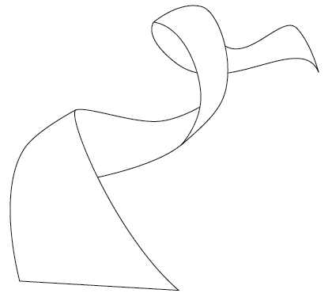

2. Photo Stack
Choose 2 or 3 photos of your choice and stack them together. They need to be 3 of your designs from this semester. You may decide to combine the designs (and flatten) in a different document and move them over.
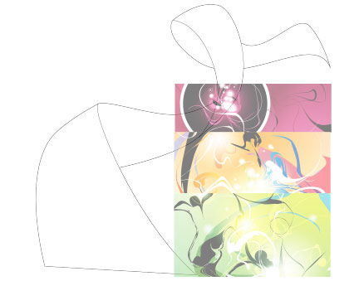

3. Warping (Photoshop Warp Tool)
Adjust the layer opacity to 40 or 50% so you can see the guideline underneath. Go to Edit > Transform > Warp. Now you should see a grid and 4 anchor points in the corner. To bend the image, simply drag the anchor points, direction points, or grid lines.
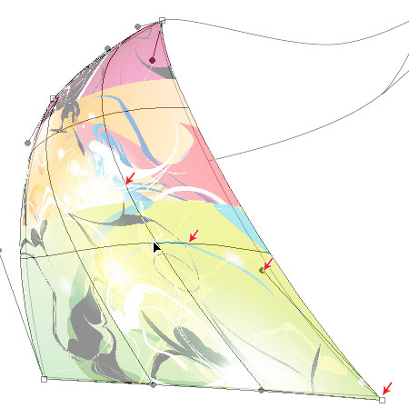
Repeat this step for the rest of the strip using more designs. This step is relatively simple and repetitive. Here are the screenshots of the steps:
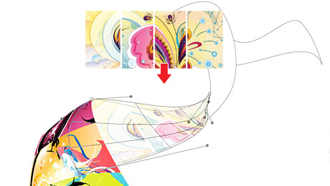
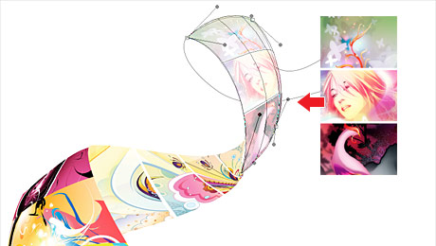
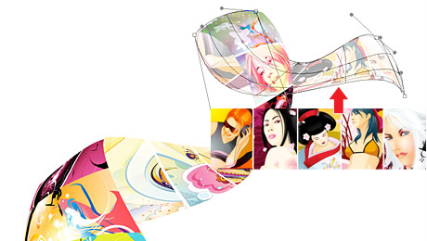

4. Masking
Organize the layers into groups (ie. strip 1, 2, 3, 4). Layer > Group Layers
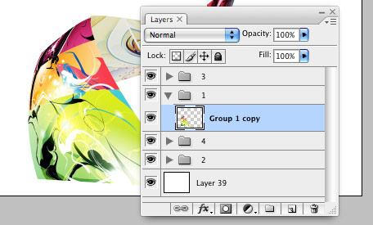
Load selection from the shapes you created in step 1 and add a layer mask for each group (so you get a perfect smooth curve).
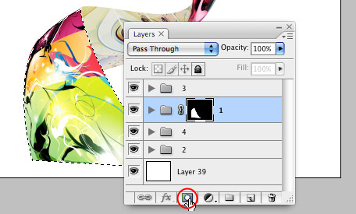

5. Shadows
In masked group 1, create a new layer above the strip. Use the Gradient tool and drag from the top to bottom to create a black gradient.
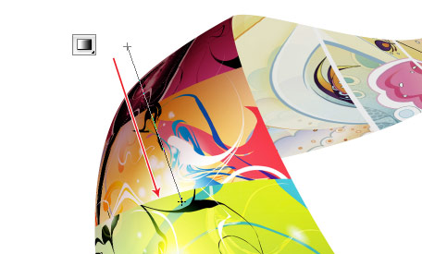
Repeat this step for the other strips.
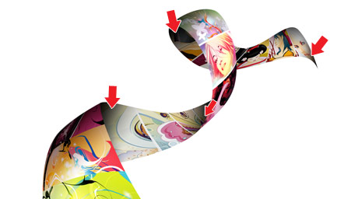

6. Highlights
To make highlighted and glossy areas: create a round glowing circle, compress it, and rotate it in the angle according to your strip's direction.
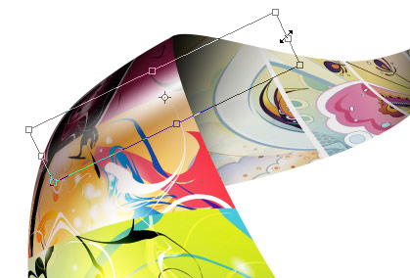

7. Line Strokes
To make line strokes: load a selection of the mask, create a new layer, fill it with black, shift the selection to the left by 1 or 2 pixels, delete the selected area by pressing the Delete key.
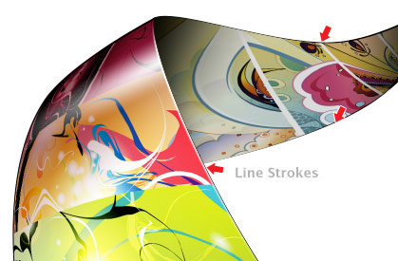

8. Final Touches
To make the image look more interesting, desaturated the two strips in the back.
