Mixer Brush Painting
There are two new features used for painting in Photoshop CS5. The first one is the new Brush Tip options.
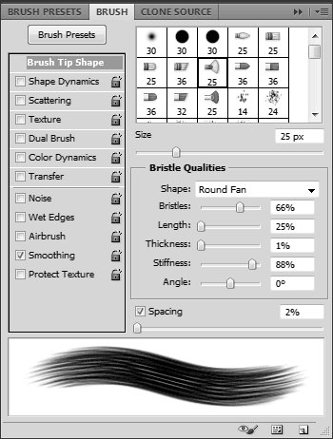
New options in the Brushes Panel
With the new brushes, you can control the number of bristles, length, thickness and stiffness and not only can you see the result in the brush panel, you also get an overlay window that shows you the 3D virtual brush and its bristles.
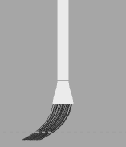
Paint Preview
The second ingredient in the digital paint toolbox is the Mixer Brush. The Mixer Brush is like a combination of the normal brush and the smudge tool. As you paint, it smudges and mixes the color, as if you were using wet paints.
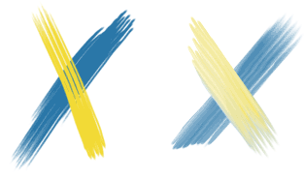
Regular brush (left) and Mixing brush (right)
The way the brush color is mixed with the canvas is controlled by three parameters – the wetness of the paint, the load of the brush and the mix amount between the paint color and the canvas color.
Mixing Brush Parameters
To illustrate these parameters, I brushed quickly over an image with different settings:
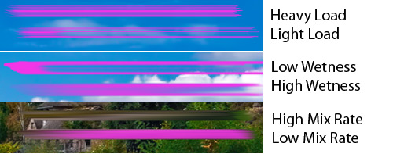
Different Mixing Brush options
So, a heavy load will carry more paint over a stroke than a light load; wetness smudges and mixes the canvas color with the paint color; a high mix rate will use more of the canvas color than the paint color.
The real magic with the Mixing Brush is that you can paint using the colors from a picture, effectively helping to you turn a photo into a painting with little effort.

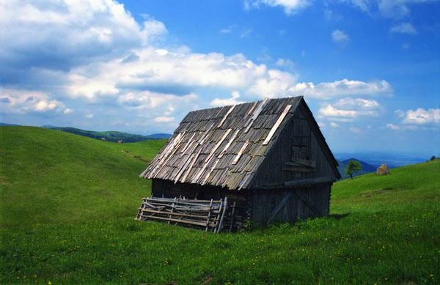
The original photo
GETTING STARTED –
Open Image (File > Open) of your choice. I would recommend a landscape scene with a piece of architecture. You will need foreground, mid-ground, and background.
Resize your image. Image > Image Size > Check Resample Image & Constrain Proportions & Scale Styles, also change Document Size = Width 8.5. If your image is really pixelated you will need to find a new one. This means the resolution is poor.
CREATE A NEW LAYER (NAME IT “MIXER BACKGOUND”) Select the Mixer Bush and from the top options bar choose the preset Very Wet, Heavy Mix; choose the brush that you want from the Brushes panel and make it a big size. Make sure the option Sample All Layers at the top is selected.
Paint on the new layer using the colors from the background, with the Mixer Brush tool selected. Deselect the icon (Load the brush after each stroke) then Alt-click on the image to load the brush and start painting on the new layer.
To paint effectively, you need to think in terms of layers, from background to foreground and from broad to detail. Therefore we’ll start painting the background, using broad strokes with a large brush tip, ignoring the shack/cabin completely. Your strokes should more or less follow the contours of the terrain and clouds.
Hide the background layer temporarily to see the effect so far:
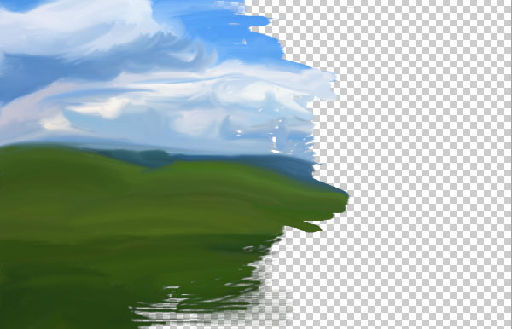
Background (landscape) layer – work in progress
As you can see, I smudged the colors over the shack as if it did not exist. Also, notice how my strokes follow the hills and the shapes of the clouds. Keep working until you fill the layer and are happy with the result.
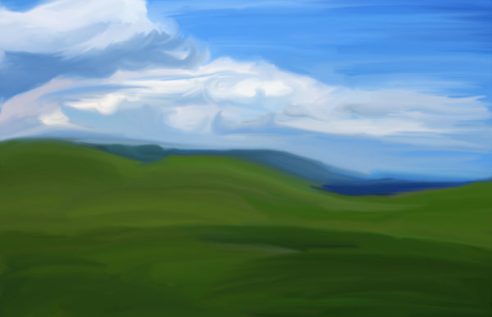
Background Landscape layer – complete

Next, we need to paint the cabin. It’s better to paint it on its own layer so that if you decide to change anything, it doesn’t mess with the background.
To do that, you need to hide the landscape layer, CREATE A NEW LAYER (NAME IT “MIXER MID-GROUND”) and paint on it. This time you’ll ignore the landscape and do just the mid-ground features. You also need to make the brush tip smaller. Make sure the background photo is visible so it can pick the colors from it.
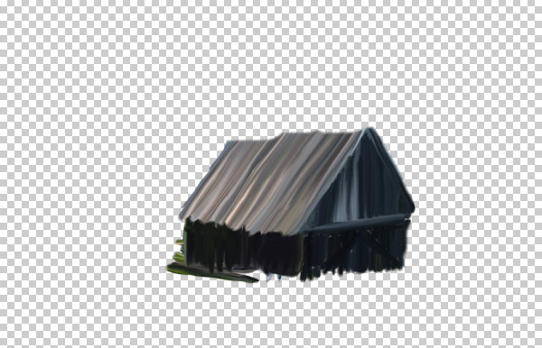
Cabin / Shack – complete
If you look at the roof, you’ll see that I erased from it some parts I did not like – this is why it’s a good practice to work on separate layer.
Now that we have the broad strokes, it’s time to bring in the details. Repeat the process – hide the shack layer, make sure the background photo is visible, make the brush tip even smaller, CREATE A NEW LAYER (NAME IT “MIXER FORGREOUND”) and start painting on it. This time you no longer need to fill all the stuff, just short, fine strokes in the areas you want detail.
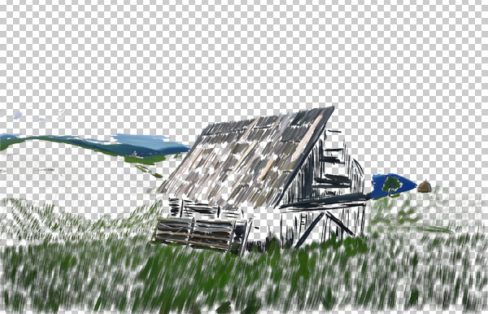
Details – distant, grass and shack
If you show all layers, this is what we get:
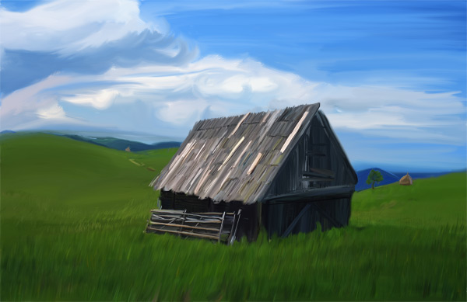
Background, foreground and detail layers
Not bad. We still want to add some more details like shadows. CREATE A NEW LAYER (NAME IT “DETAILS AND SHADOWS” and set its mode to Multiply and opacity to around 60%. Choose a Dry Mixing Brush – now we don’t need to mix with the background – just add black for color. Paint the shaded areas.
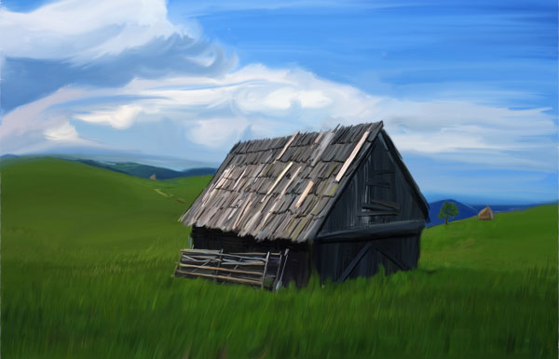
Shadows added in
At this point you can add a final touch. One of the nice things about oil paint is that it has thickness. To give this kind of tridimensional effect, you need to create a merged copy of the layers. The easy way is to duplicate all layers and then merge the copy (quickest route: select the layers by holding Shift and press Shift+CMD+OPT+E). Now you should have a new merged layer in addition to the original ones.
With this new layer selected, choose Filters –> Stylize –> Emboss and in the dialog enter some values like below:
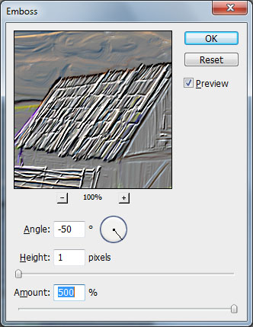
Emboss Dialog
Make sure Height is relatively small – this depends on how large your canvas is, and make sure you crank the Amount all the way to the max. You can always tone the effect down later with opacity. With this emboss layer, set the mode to Overlay.
Here’s the end result, including all the layers for reference:
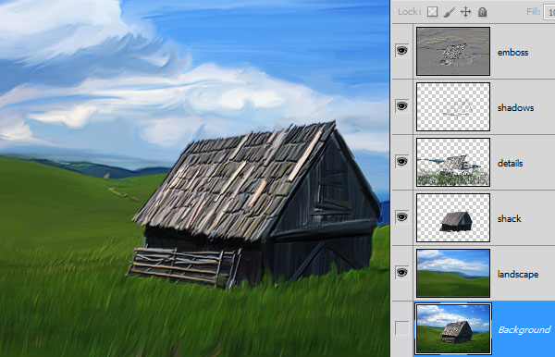

DO NOT FLATTEN YOUR FINAL PROJECT. SUBMIT TO THE DROP BOX AND ALSO SUBMIT YOUR ORIGINAL IMAGE.

