Man Ray Tutorial

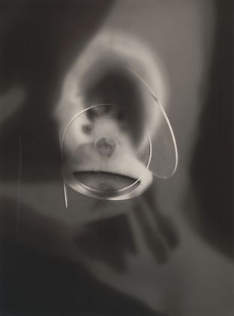

Man Ray was an American modernist artist who spent most of his career in Paris, France. He was a significant contributor to the Dada and Surrealist movements. He was best known in the art world for his avant-garde photography. Avant-garde is a French term for experimental and innovative art. Ray pushed the boundaries of traditional art.

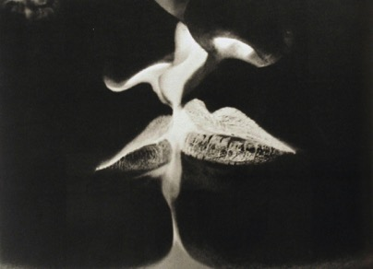
Man Ray “ Negative Kiss” 1935

Solarization is a photographic effect that gives the print the appearance of being both negative and positive at the same time. Normally it is created while developing photographs. In the darkroom it is achieved by subjecting the print to a brief second exposure during the development stage. The lightest tones of the print are affected the most by the second exposure thus altering the normal tonal values of the print.

We will create a ‘solarized’ image the easy way… with Photoshop.

- First, find an image that contains shadows and highlights. It can be a body part, tree, building, flowers… etc. File > Open in Photoshop.
- Change image to Black and White.
(Layer > New Adjustment Layer > Black and White > OK)
- Create a Curve Layer.
(Layer > New Adjustment Layer > Curves > OK)
- In the Adjustment palette: select the pencil button, hold shift down, and click different areas within the grid. Experiment with the changes in your image.
- Create another Curve Layer.
(Layer > New Adjustment Layer > Curves > OK)
- In the Adjustment palette: select the “Endpoints to modify the curve” and click different areas within the grid. Experiment with the changes in your image.
A small bend can have a massive effect.
- Create a New Layer.
(Layer > New > Layer > OK)
- Apply image to new layer.
(Image > Apply Image > OK)
- Select Dodge Tool to lighten areas in your image. Modify the Option Bar to select shadows, mid-tones, or highlights.
Select Burn Tool to darken areas in your image. Modify the Option Bar to select shadows, mid-tones, or highlights.

File > Place another image into your design, modify using solarization technique as outlined in Steps 2-9.
Blend it into your final design using Blending Modes & Opacity.

USING IMAGE > ADJUSTMENTS > INVERT you will reverse the areas of black/white to create the negative.

Save > Lastname_FirstnameMAN
Turn in to the Drop Box.
Screen Shot your work for Canvas.

