Low Polygon Images
Part 1
- Prep your document: Open your image, using Image Size verify that your image is a suitable size. Nothing smaller than 7” by 7”. Your image needs to be symmetrical. Save As > Name, Low Poly.
- Activate Rulers.
- View > Show > Grid. Preferences > Guides, Grid, & Slices. Style > Lines = 20 Pixels and 1 Subdivisions. Color should be set to Gray (808080).
- Activate Snap Grid. View > Snap To > Grid
- Command J to copy layer.
- Z (Zoom) and zoom into the eye. Hold Spacebar to reposition the eye.
- Polygonal Lasso Tool, uncheck Anti-Alias (This removes transparent edges from your selections).
- Start on the eyes. We are only changing half of the face. Polygons are triangular in shape and their sizes should correspond with the areas in your image that have specific angles and consistent colors or tonal value.
- Make a polygon selection, click two corners and complete your path on the third point. (Complete Path)
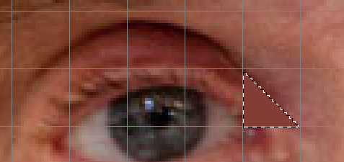
- With your selection active, Filter > Blur > Average. This will apply a general value to your selection. Command D to deactivate your selection.
- Continue onto the next polygon. Remember, start with two corners and end with your third point. Command F will apply the last filter you used. Command D to deactivate your selection.
- Fill polygons around the eye. NO gaps, holes, or open spots! Vary size, color, and direction. Create larger polygons as you spread to the larger parts of the face.
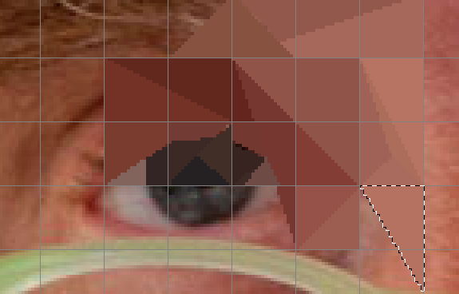
- Finally, create a white, polygon highlight on the eye.

Part 2
- Rectangular Marquee Tool, select the left side of the portrait.
- Command J to cut/copy to a new layer.
- Command T (Free Transform) use the horizontal double arrow to drag across and press Return.
- Adjustments > Levels with a Clipping Mask. This will apply the adjustment only to the layer directly below. In Levels, take Input Mid-tones to the right.
- Command H to hide grid.
- Save as PSD and JPEG. Drop Box.
- Your second image can be another symmetrical design. Try to fill polygons with alternate colors. Use the shortcut Option Delete to fill with foreground color. Also, save colors to you Swatches Window.

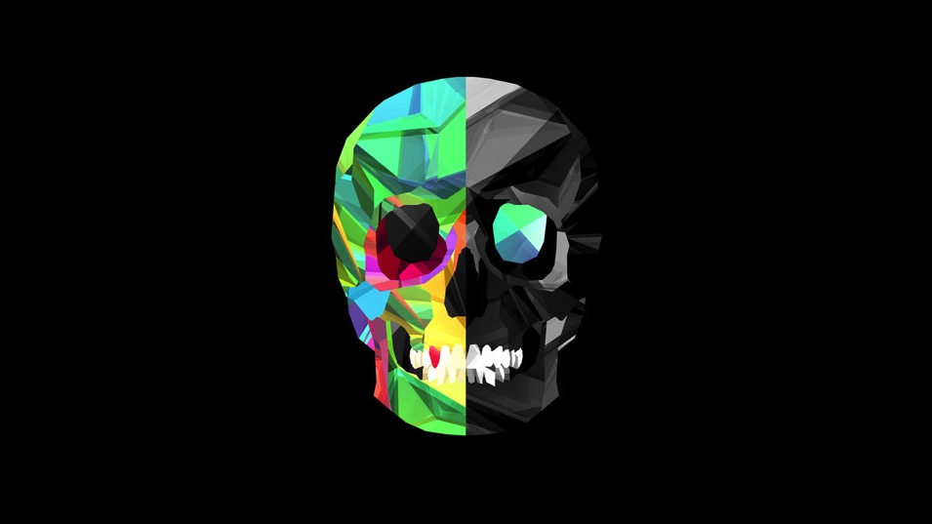
Copyright - Justin Maller

