Impressionist Painting Effect

Characteristics of Impressionism
- 19th century art movement
- Originated in Paris
- Colors placed side by side with little mixing
- LIGHT and its ever changing qualities
- Unusual angles in composition

A few well known Impressionist artists
- Claude Monet
- Pierre-Auguste Renoir
- Alfred Sisley

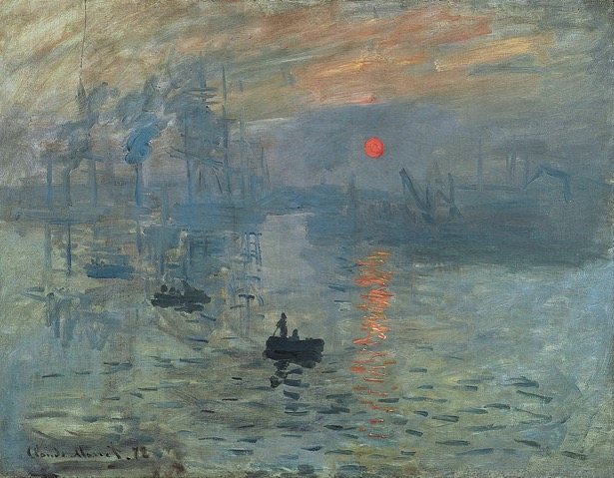
Claude Monet “Impression, Sunrise” 1872

In this tutorial you will modify these characteristics within a photograph to create your own Impressionist style. You will use your own photo, so some settings may vary.

Emphasize Texture and Color
Step 1: File > Open your image

Step 2: Duplicate the background layer. (Layer > Duplicate Layer)
Step 3: Double-click on the Foreground color icon. Set the foreground color in the toolbox to a light gray tone. Within the CMYK setting you can set Cyan to 0, Magenta to 0, Yellow to 0, and Black (K) to 20%.

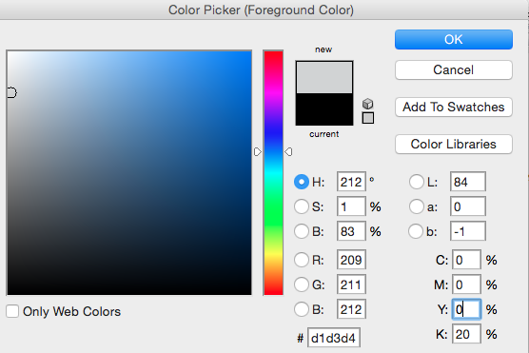

Step 4: Click on Filter > Sketch > Chalk & Charcoal. Use settings below.

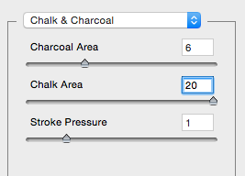

Step 5: Click on Filter > Brush Stroke > Spatter. Use settings below.

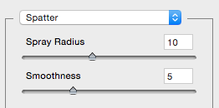

Step 6: Change the current layer blend mode to Luminosity.

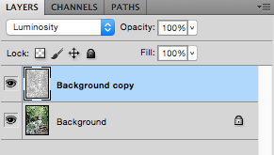

Step 7: Duplicate the original background layer and drag it on top of the other layers.

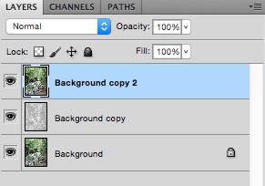

Step 8: Using Shift key, select the two bottom layers and merge them (Command E).

Step 9: You should have two layers. Select the top layer and change the layer blend mode to Multiply.

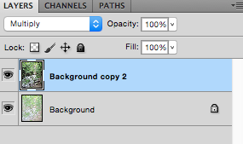

Step 10: Click on Image > Adjustments > Brightness/Contrast. Use settings below.

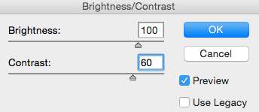

Step 11: Click on Filter > Artistic > Underpainting. Use settings below.

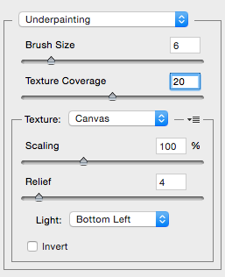

Step 12: Click on Edit > Fade Underpainting. Set the fade mode to Hard Light.

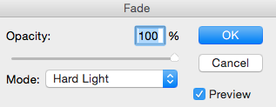

Step 13: Layer > Flatten Image to flatten the image. This condenses all open layers into one.

Step 14: Click on Image > Adjustments > Selective Color and fine tune the colors and values. It is important to remember that you are creating a final image that may reflect distorted color. Work with Reds, Yellows, Greens, Magentas, Cyan, Blues, Whites, Neutrals, and Blacks until you feel the Impressionist style has been achieved. Your Selective Color windows will look different from these examples.

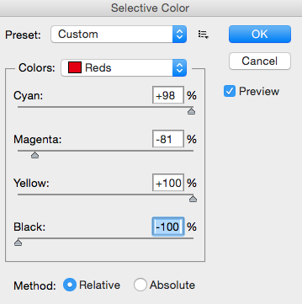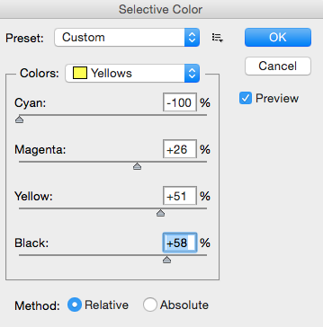

Before After
