Step 5
Repeat same operation as before but this time with white color, on a new layer “Iris Texture White”, set its Blending Mode to Soft Light and Opacity to 100%.
Iris usually has a darker area on the edge, use the Wand Tool (W) to select the shape of the iris (select Right Iris Layer). Create a new layer “Iris Stroke”, set its Blending Mode to Multiply and Opacity to 60%, and go to Edit > Stroke, choose Inside Location, and make a stroke of 10 pixels wide, following with the Smudge Tool, smudge a bit to integrate it better on the texture.
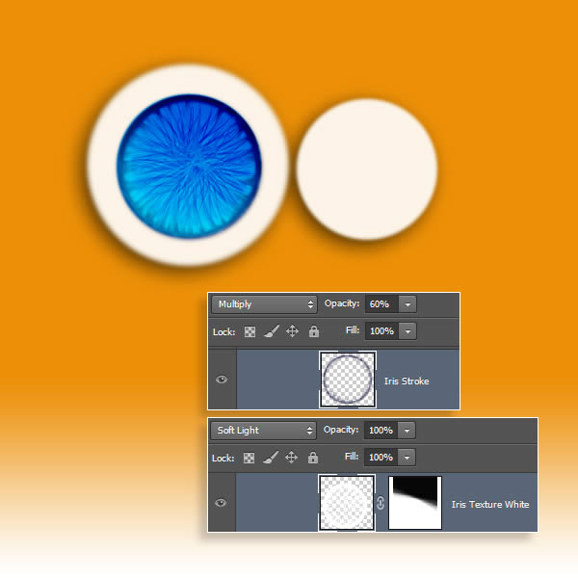

Step 6
Iris still needs to appear more concave, duplicate the “Concave Shadow” layer and set its Blending Mode to Multiply and Opacity to 90%, now we get a deeper finish.
Next, it’s time for lights, create a new layer “Concave Light 1″ set its Blending Mode to Luminosity and leave Opacity to 100%, on it, paint a white ring smaller that the iris diameter, use a soft round brush to do it with low opacity, next create another layer “Concave Light 2″ set its Blending Mode to Lighten and 57% of Opacity, intensify light on the lower area with some extra white color strokes, and use the Smudge Tool to imitate the iris surface.
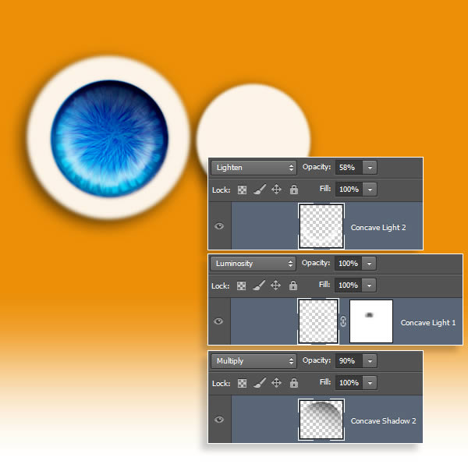

Step 7
Next, paint the pupil, create a new layer “Pupil”, leave its default layer settings, and paint a black dot placed on the center of the iris, with the Smudge Tool degrade a bit its edges. Now we will add the reflective finish of the eye, create a new layer “Retina Brightness”, leave its default layer settings, paint a white dot on the top right, and smudge the edges a bit with the Smudge Tool. To simulate reflectivity, also paint and smudge a blue and orange stroke on the bottom left, to render reflections of the blue light and surrounding orange hair.
On all reflected surfaces there are a high contrast between light and shadow, to achieve it, create a new layer "Retina Shadow" leave its Blending Mode to Normal and set Opacity to 60%, place the layer below iris and pupil layers. Make a selection of the retina and paint a gradient from black to transparent starting on the bottom left area, just on the opposite place of the light. Finally, following with the reflective finishing, create a new layer "Orange Tint" set its Blending Mode to Multiply and 30% of Opacity, make a selection of the eye and fill it with background’s orange color, with this, eye surface will reflect the fur orange color around it.
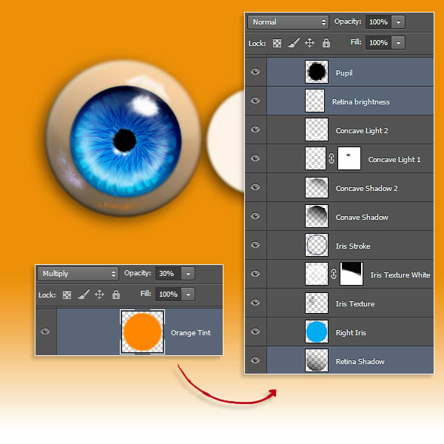

Step 8
Merge all visible layers that were used for render the eye, except the “Eyes Base” layer, we will have a resulting layer, call it “Right Eye," duplicate it , rename it “Left Eye” and go to Edit > Transform > Scale, for resize the left eye, with the Move Tool (V) take up its place. Merge all the eye layers.
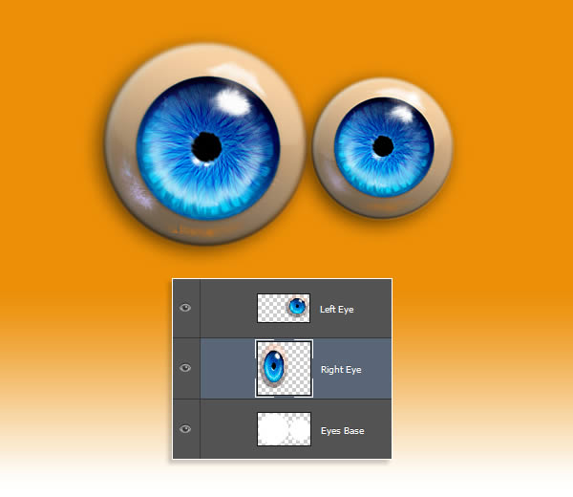

Step 9
Eyes finished it’s time to start with the body, create a new layer over the “Orange b
Background” layer, pick the Soft Round Brush, select black color, and start painting the shape of the body, just sketching the main forms. Now, go to Filter > Liquify and with the Forward Warp Tool (W) detail the forms with more accuracy, as arms, legs, cheeks and head shape.
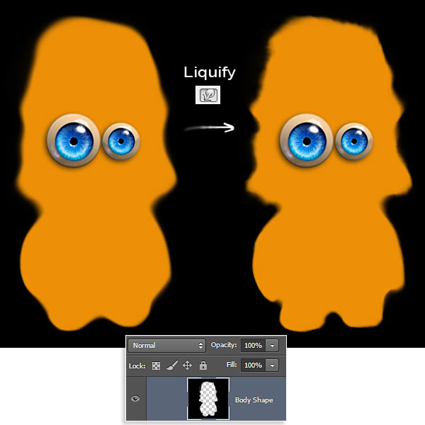

Step 10
Now, we will add detail on the edge, for it, first use the Smudge Tool with the Hard Round Pressure Size brush, start making the bigger tufts, adjust brush size during the process to have betters results, more randomness more real the fur looks like, also modify direction and angle of the strokes while you are painting.
On the next phase, use the Spatter 14px brush, this brush gives a more choppy effect; again, modify size and angle to get the best results. Use lower brush size to create thin hairs, followed by the Smudge Tool to crimp them a bit.
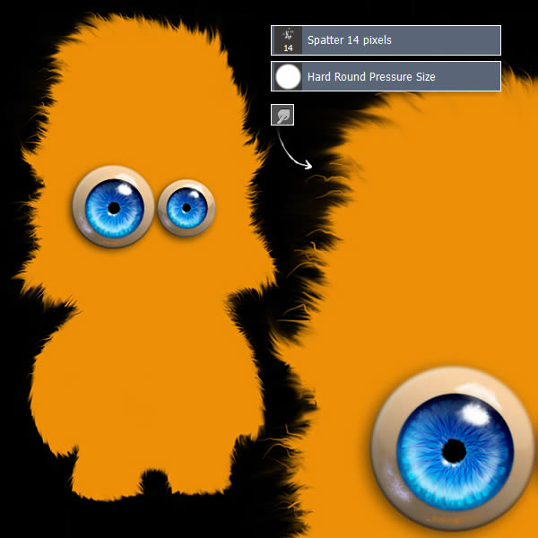

Step 11
Next, we will add the eyebrows, create a new layer “Eyebrows”, placed over the eyes layer, make a rectangular selection over the eyes with the Rectangular Marquee Tool (M) and fill it with orange’s body color, then apply a Layer Style, Drop Shadow and adjust settings as shown. With the Smudge Tool again and Spatter 14px brush create the hair, as layer has drop shadow, each stroke we make will project its own shadow giving us the depth effect.
