Step 15
Adjust the opacity of the “Fur Layer” and then remove visibility for the next step.
On the next step we will add a lateral blue light which will enrich our color palette, create a new layer “Blue Light” set its Blending Mode to Color leave Opacity to 100%, pick a Soft Round brush and paint a stroke on the character’s left side, next use the Smudge Tool and the Spatter 14px Brush to break the stroke, and integrate it on the fur texture.
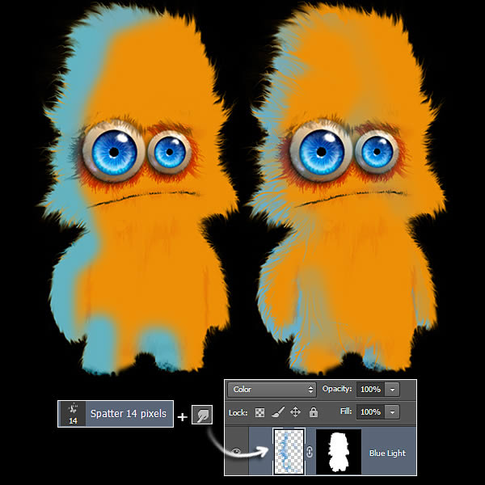

Step 16
Make Fur Layer visible again and start to paint the finishing fur over the base that we created from a real fur picture. Pick the brush we created on Step 4, and go to the Brush Setting Palette (Window > Brush), where we will have to play with different controls on the Brush Tip Shape area. First, the Brush Size, to get different hair sizes, depending of what part of the body, they will be longer or shorter. Another control to adjust is the Angle, will be necessary to adjust it to place hairs on the right flowing position, as we saw on Step 14. And, finally, Spacing control to adjust how separated hairs will be, on open areas as belly, hairs are more scattered, an on cheeks are closer each other.
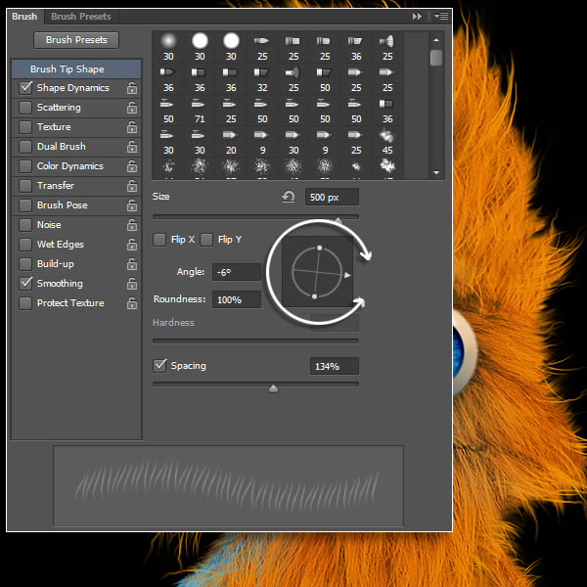

Step 17
With the brush Shape Dynamics settings we will have more control our hair strokes, adjust Angle Jitter to create disheveled hairs, and Roundness Jitter control, to get more hair waviness. Let’s have some fun with our hair.
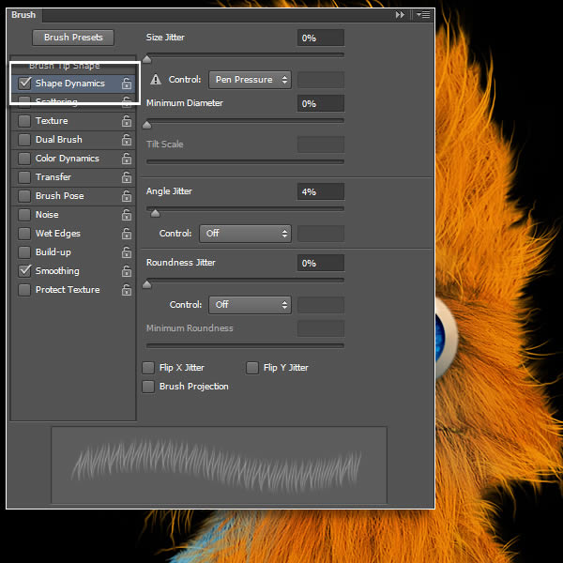

Step 18
Fur will be build on two layers, "Orange Fur" layer, were we will use a lighter orange than body’s color, and "White Fur" layer, were we will paint white hairs, both in Normal mode and 100% Opacity. White fur must be over the orange fur layer. As you can see in the image below don’t try to cover whole body of hair strokes, just add hair on some areas, which will help to get a more complete fur surface. We will add an extra layer "Under Eyebrows Fur" where we will paint some darker orange hair strokes, to get more shadows on that area.
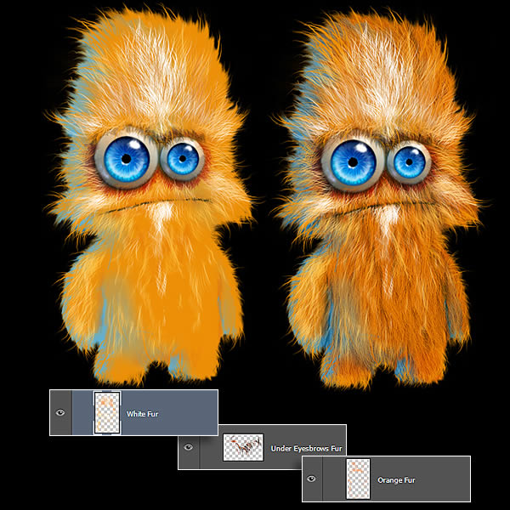

Step 19 - Conclusion
To curl a little more hair, and make some flow corrections, use the Smudge Tool with high Strength, then push hairs to get a more detailed finishing.
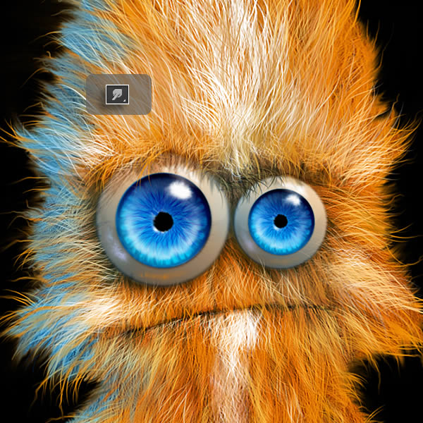

Save your finished project Unflattenened.

