Step 12
Using the fur image provided in your computer graphics folder, we will create the fur base of our character. Start selecting areas of fur with the Polygonal Lasso Tool from the picture, then copy and paste them to create different fur layers, once the selection is placed on a new layer, move or rotate it to match the hair direction, arrows on the pic shows how hair must flow on the body, head and tips. In some cases will be necessary to use the Warp Transform Tool to fix them.
Next, hide the undesired areas of each clipping with Layer Masks, leave a small part of each piece of hair to cover the adjacent, avoiding blank spaces without texture. (Layer > Layer Mask > Hide All) Paint with a white brush the areas you want to show through.
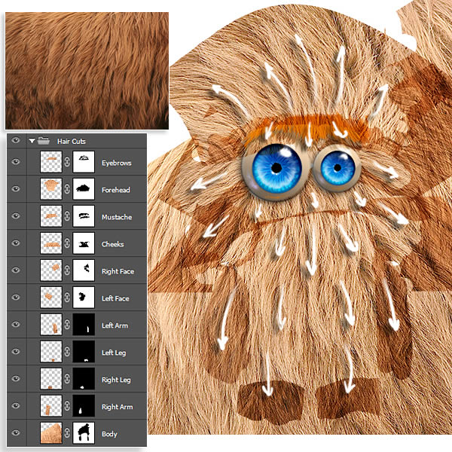

Step 13
Now, we will "weld" each cut of hair, first of all, set Blending Mode of each all layers to Multiply and 100% Opacity, made this, on each Layer Mask, use the Smudge Tool with the Spatter 14px brush to integrate adjacent hairs, follow the direction of the hair to avoid hard cuts. Setting the Strength of the stroke during the process will help to get better results. Remember that we are not painting, we just leave the underneath layer, using the Layer Mask’s transparency, so to complete the process on some areas will be necessary to paint on the Layer Mask with white or black to show or hide portions of hair. You can create a selection of your eyebrow (Command & click on Eyebrow Thumbnail) and cut an exact shape from your fur image.
Then we will merge all the fur layers (Layer > Merge Layers), set the Blending Mode to Multiply, and go to Filters > Sharpen > Smart Sharpen, and apply a sharpen amount of 50%.
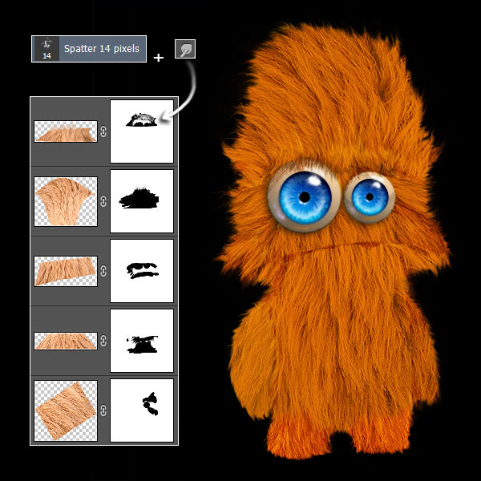

Step 14
Character needs mouth to complete his expression, create a new layer "Mouth", set its Blending Mode to Multiply and 100% Opacity, pick a hard round brush, set it size about 3 pixels and paint the mouth’s line, afterwards using the Smudge Tool break the stroke a bit to simulate surrounding hair. We still have the body without any volume, to fix it add red shadows around the eyes in “Body Layer”. Also, create another layer and set its Blending Modes and Opacities as shown, what we will do is painting shadows to block out forms as arms, chin, eyes sockets and so on, play with Opacity.
