Illustration
When you design characters, it is best to start by sketching an outline to find the shape and proportions. A good outline helps to get the base of what will be the final creation.
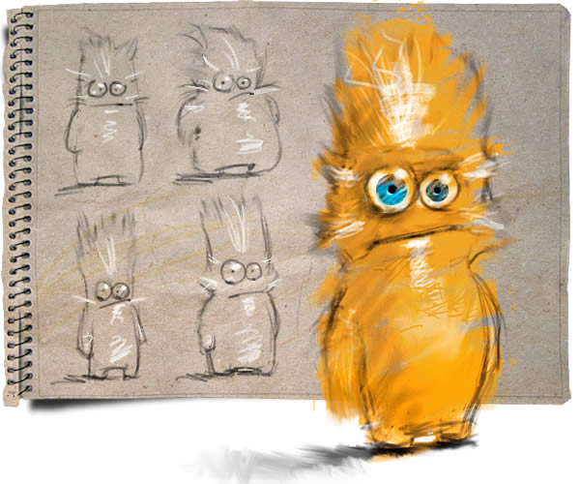

Step 1
Once the idea is clear, let’s start creating. Open a new document (US Paper) and fill it with a bright orange color. Next, I start with the eyes, for me they are the center of the character, where you can find most of his personality, and, why are they asymmetrical? The answer is just personal preferences; I tend to draw eyes on this way on my characters. So, first create a new layer, "Eyes Base". Draw two circular selections with the Elliptical Marquee Tool (M), and fill that selection with white color, next, apply Layer Style, Drop Shadow as shown.
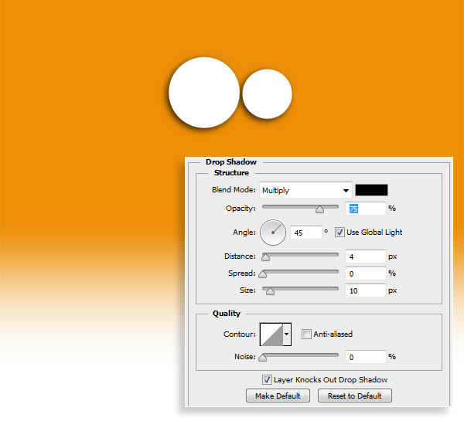

Step 2
Now, let’s create the iris, to save time we will create one eye, and then copy and paste it on the other one afterwards. Create a new layer “Right Iris”. Draw a circular selection with the Elliptical Marquee Tool (M) on the middle of the white circle (Option), and fill that selection with light blue color. To render its concavity, create a new layer “Concave Shadow”, set its Blending Mode to Overlay and 100% Opacity, and apply a gradient from black to transparent as shown. Remove selection (Command D) and change Foreground color to black before continuing on.
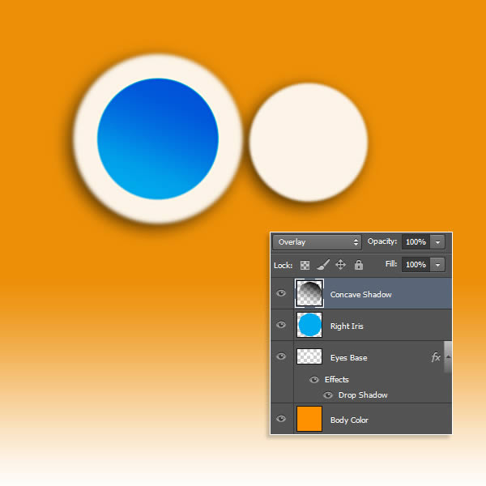

Step 3
For the iris texture will be necessary to create a custom brush, which subsequently will be useful for the fur also. Hide the previous layers we created before, create a new one, and with the Pen Tool (P) create a vertical line, next, with the Convert Point Tool, bend it as shown. Now, in Untitled Brushes, select Flat Point Medium Stiff, then go to the Path Palette > Stroke Path, check that Simulate Pressure is marked, play with the size of the brush to get a thin line with degraded borders. Unselect the ‘work path’ in the Path Palette and select your curved line using the Rectangular Marquee Tool. Now go to Edit > Define Brush Preset and save the shape as fur brush or whatever you want. This layer can now be deleted and you may activate visibility in the other layers. Remove selection (Command D).
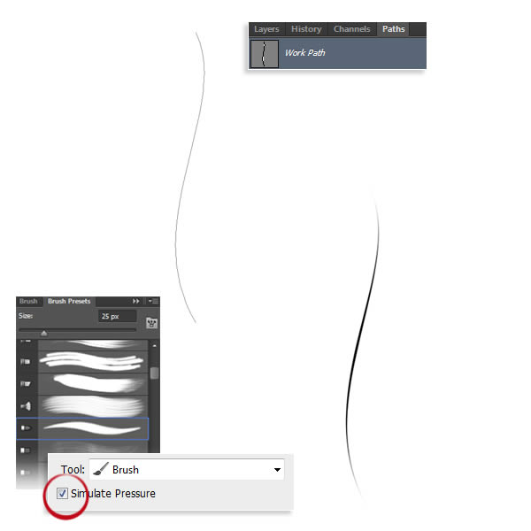

Step 4
Once brush is created, it’s time to adjust its settings. Select the Fur Brush and on the Brush Tip Shape tab adjust Spacing slider, and on the Shape Dynamics tab tweak controls as shown, play with them making some tests till get necessary behavior, idea is to paint a radial iris texture. Create a new layer “Iris Texture”, placed below “Concave Shadow” layer, set its Blending Mode to Soft Light, and Opacity to 100% pick black color and paint the texture, after with the Smudge Tool, transform a bit to make it a bit more irregular.
