How to Design A Magazine Cover in Photoshop
In this tutorial we will learn how to design a magazine cover in Photoshop. When you set out to design your own magazine cover you’ll need to pay close attention to details and carefully lay out the artistic aspect of it, working towards a well planned and complete artistic concept.
Taking the time to formulate a strong concept is extremely important to the success of the magazine. I will take you through the process of creating a cover and reveal techniques that designers use to make their covers stand out.

You do not need to use the same colors and images as this tutorial. Use your own ideas to manipulate the final product.

Step 1 : Radial Gradient Background
Create a new document in Photoshop, 8.5×11 inches, 300dpi (for printing), RGB color. Unlock your background layer and begin with a radial gradient. You can access a radial gradient by double clicking the background layer to activate the Layer Styles menu, then apply a Gradient Overlay.

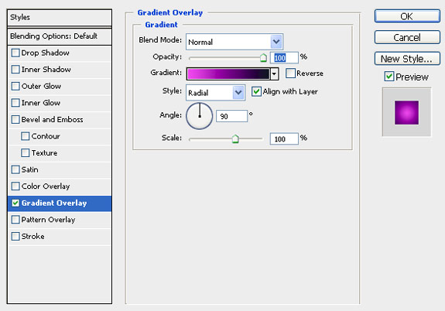

Step 2
Find a city scene and drag it above the radial gradient and change the blending mode (In Layers Palette) to Soft Light.

Step 3
Find a moon and drag it above the City layer, use a large, soft eraser bush and erase, the edges. Change the blending mode to Screen – Opacity to 20%.

Step 4
Now we will generate some Photoshop clouds to soften up the background a little more. Create a new layer and fill it with black. Generate the clouds by pressing Filter > Render > Clouds (make sure your colors are set to black and white). I also used a large soft eraser brush to erase the top of my clouds.
Change the Blending Mode to Soft Light at 35% Opacity

Step 5
Now we will create a subtle yellow glow. Create a new layer, draw a circle with the Elliptical Marquee Tool and fill it with yellow (With Bucket Tool).

Filter > Blur > Gaussian Blur
Apply a Gaussian Blur with a Radius of 114 pixels. Lower the Opacity to 45%

Step 6
Find a person to use as your subject and use the pen tool to cut out from the background.
After you are done drawing your path with the pen tool. Create a selection from the path. Go to the Path tab in the layers menu and click the Load Path as Selection tool (Third symbol with the dotted lines).

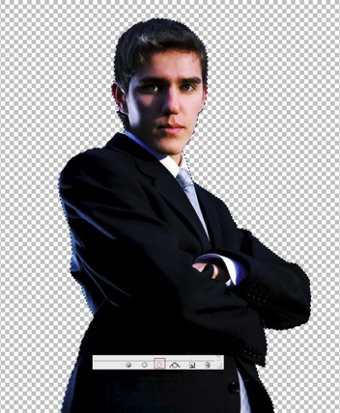

Copy your subject and paste it inside your magazine document, above all the other layers.

Step 7
Now we will add some graphic flare to the cover for some extra pop! Use the Rectangular Marquee Tool to draw a rectangular selection and then create a Layer > New Fill Layer > Gradient. Add a gradient from white to transparent to the selection.
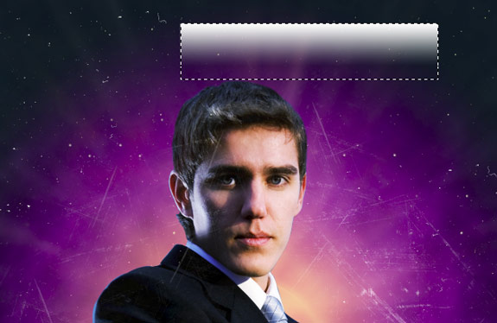
Erase the edge of the gradient with a large soft eraser brush.

Change the blending mode of the gradient to Overlay. Rotate the gradient and place it in selected areas over the model. I did this by duplicating the layer over and over again and placing them until I feel I had balance in the image.

Add a color balance layer above all the current layers, with the settings below, this will help to brighten the image and tie all the colors together.

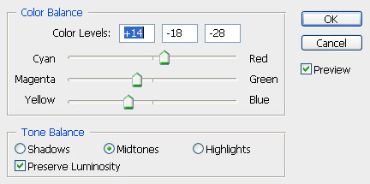

Step 8
First drag in some margin lines at 0.25 inch to keep your text away from the edge. Create a Masthead for your magazine, (The term “Masthead” is often used to refer to the nameplate of a publication, its designed title as it appears on its front page.).
I created a simple but strong masthead with Helvetica Roman Font. Place the Masthead behind the model, this overlapping technique, helps to create depth. I also included the publication date and the mission statement of the magazine. (Before you create your Masthead, research some magazines for inspiration on design and placement.)
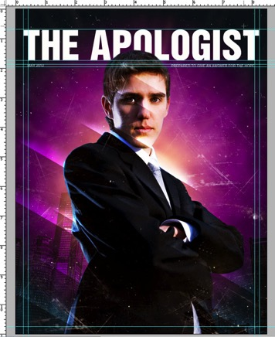

Step 9
Create several story line titles around and over the model.
- Main Story Title. Here I used a large font to pull the readers eyes.
- Secondary Story Title. Here I used a smaller font, but color and a transparent box.
- Here I used different size fonts to separate Title and Sub Titles.
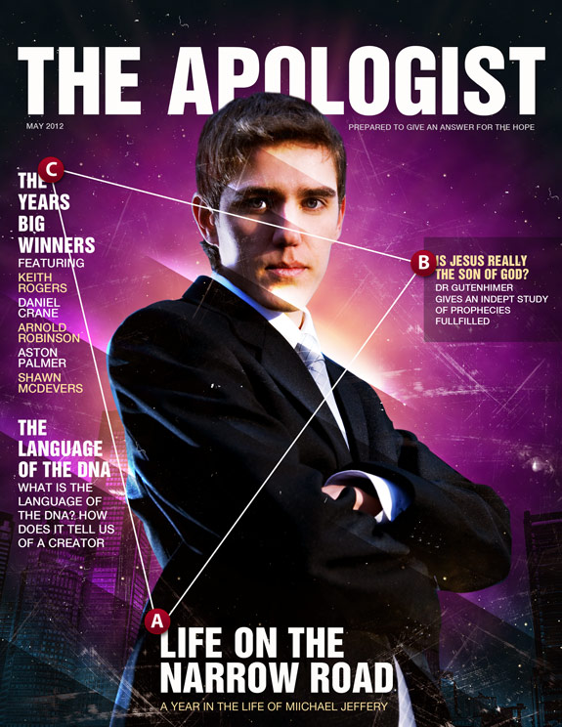

Step 10
Now we will finish up our magazine by adding a barcode.

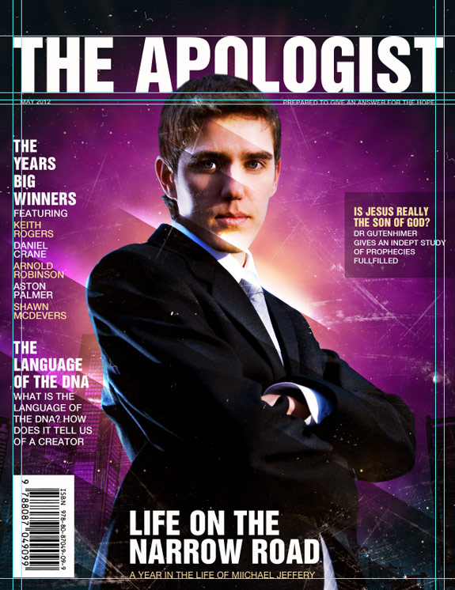

Final Image

Conclusion
You can play a little bit more with color to achieve different moods for the magazine.

