Create a Raw Horror Movie Poster Design in Photoshop
We’ll create a low-fi print effect with red on black and use a range of splatter brushes to rough up the design and capture the horror theme.
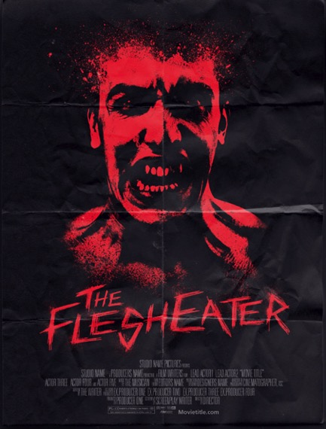

1. Find a subject for your poster and drag into New Document (US PAPER). The horror movie poster design we’ll be creating features a scary looking infected zombie fellow or you could use someone screaming.

2. Create a black background underneath your image.
(Layer > New Layer) (Edit > Fill ; select Black)
3. Go back to your image in the Layers Palette and select the image with Pen Tool.
(Make it a selection through Path.)
Also, delete background and let black layer show through.
(Select > Inverse > Delete button)
Deselect – (Command D)
4. Add a black to white Gradient Map to quickly convert the image to black and white.
(Go to Image > Adjustments > Black and White > OK)
Do not select B/W in ADJ window.
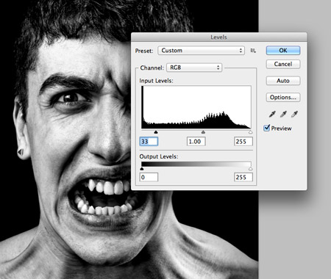
5. Go to Image > Adjustments > Levels and increase the contrast by dragging the shadows marker to darken the photo.
Input Levels:
Move black right and move white left.
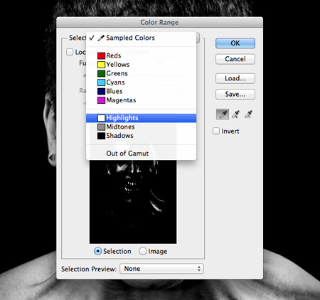
6. Go to Select > Color Range and change the Selection to Highlights in the drop down menu, OK.
Press CMD+C to copy the selection then press CMD J to paste to a new layer.
7. Delete original image layer.
Now you should have a black background and white highlights layer.
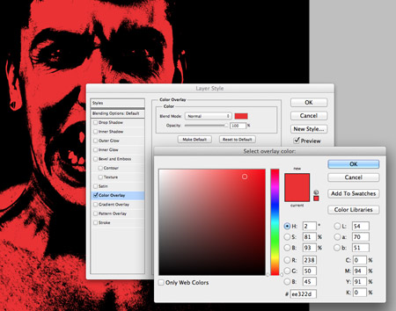
8. Add a red Color Overlay.
(Have white highlights layer selected: Layer > Layer Style > Color Overlay)
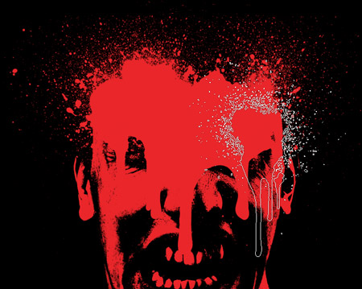
9. Create a new layer (Layer > New > Layer). Instead of showing a neat hairline on top of the zombie’s
head, we’ll add a few gory blood splatters. Use a range of splatter brushes to add various splatters on the
new layer. Don’t worry too much about painting over the facial features, pay more attention to the
pattern of drips and splatters.
(Have your Brush Tool selected and Window > Brush Presets)
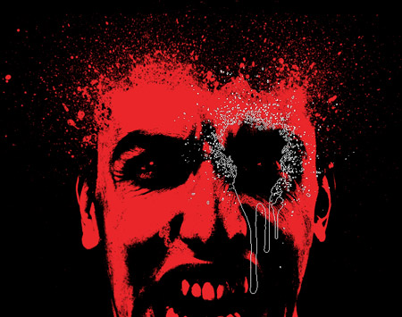
10. Add a Layer Mask to the blood splatters layer and use similar spray paint brushes to paint away the
excess that hides the facial areas.
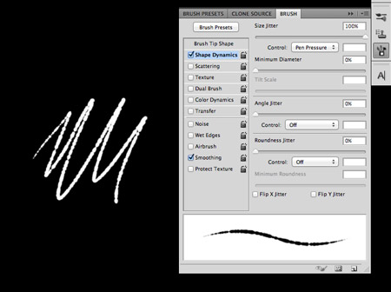
11. Create a new document with a transparent background and set up a new brush.
Choose a small hard nib, then increase the Size Jitter and
Spacing in the Brush options to create a rough and irregular line.
(Go to Brush within your Brush Presets)
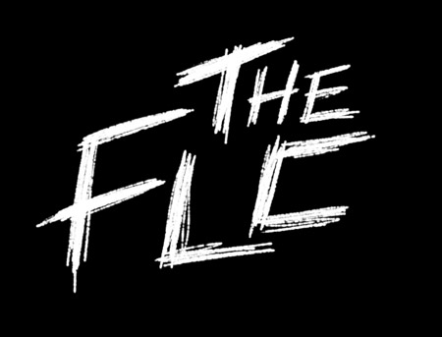
12. Use this new brush to roughly sketch out the title of the movie. I’m creating the words “The Flesheater” with very rough and thrashy lines.
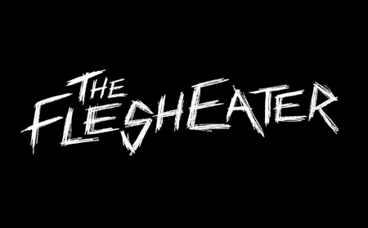
Creating the text by hand helps avoid any duplicated letters that can result from using decorative fonts. Also, being a horror movie design the titles are often engraved, carved or created from blood splatters, so they’re easy to create manually.
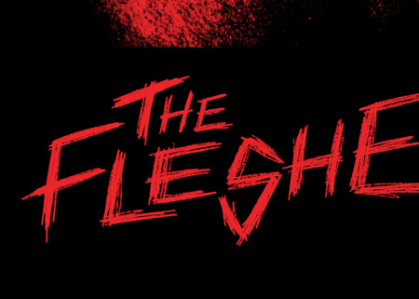
13. Paste the title into the main poster document and add a Color Overlay to match the red theme of the
design.
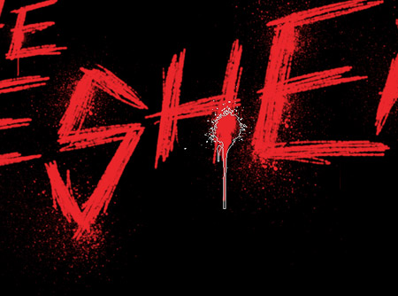
14. Use the spray paint brushes, this time at a much smaller scale, to add a range of drips and splatters
around the text to give it more of a gory horror style.
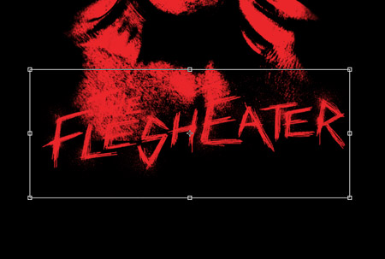
15. Move the title into a prominent position in the poster document. It might end up overlapping the
character and being lost in the background.
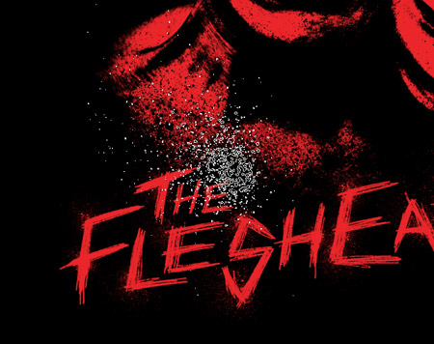
16. Use the spray paint brushes once again to paint away the lower portion of the character using black on a
new layer. These spray paint splatters do a great job of matching the rough texture of the zombie layer.
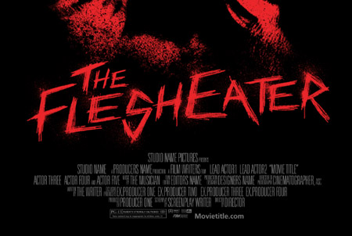
17. Add some generic movie credits to create a more realistic movie poster.
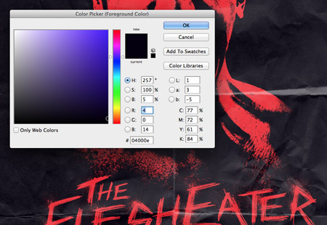
18. Finally, to give the design a slightly more retro and aged appearance, add a new layer filled with a very
dark blue or you can try applying a texture overlay. Change this layer mode to Screen to give the black areas a subtle blue tint, which helps capture
the faded ink effect seen on old prints.
You will need to adjust the opacity of the layer within the Layers Palette.
(In the Layers Palette under ‘Normal’ you will find ‘Screen’)

