Glowing Lights

Step 1
Create a new document (Width 11 inches and Height 8.5 inches) and place background image. Make sure it fills the document.
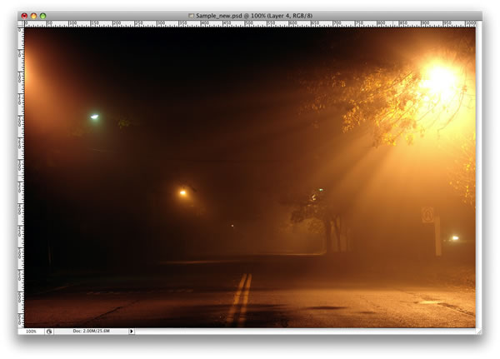

Step 2
Here I placed a second image. I will use it to create the light effects.
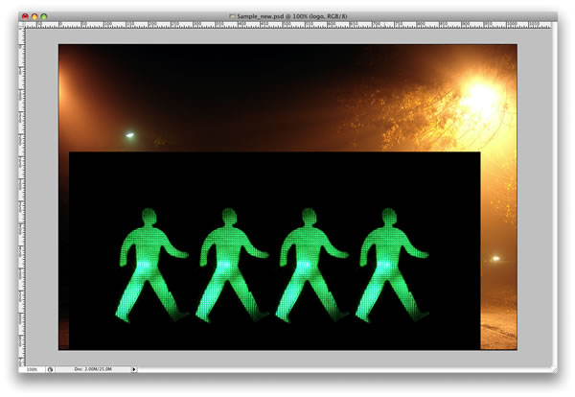

Step 3
With the Pen Tool(P), create a path for one of the figures.
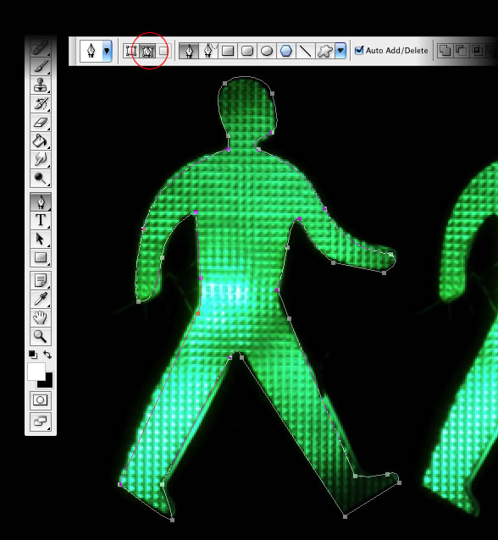

When you finish with the Pen Tool, remove visibility of Glowing People Layer.

Step 4
Select the Brush Tool and go to Window>Brush to create our brush specifications. Use 12px for the size and select Shape Dynamics (Minimum Diameter 27%) and Dual Brush.

Step 5
Go to the Layer Palette, create a new folder/group, and Rename it Lights. After that, create a new layer inside this folder (Layer > New Layer), name it “dude”, and select it.
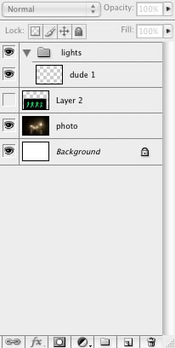

Step 6

Change Foreground Color to Yellow.
Go to the Path Palette and select the first path. Select the dialog box (Upper Right Corner of Paths Palette), Stroke Path, select Brush and check Simulate Pressure.
After that go to Filter>Blur>Gaussian Blur, use 1.6px for the amount.
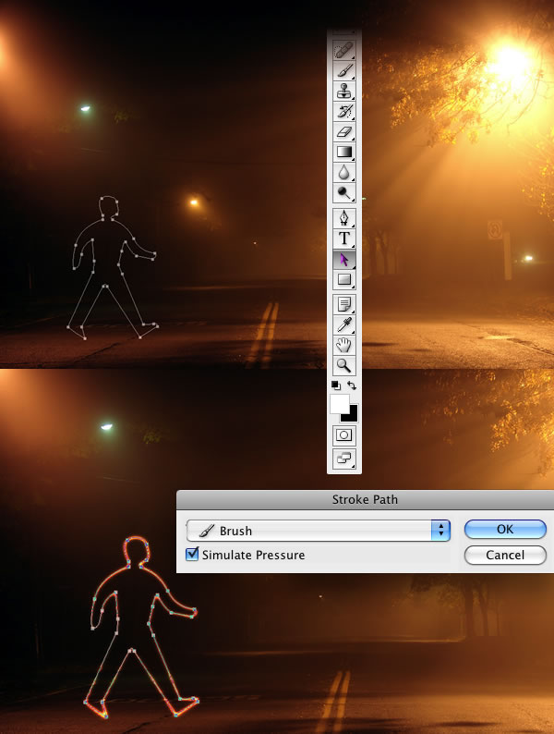

Step 7
Duplicate the “dude” layer three times. You should have 4 Dude Layers within Group 1. Move Dude 2,3, and 4 across the page as shown below.
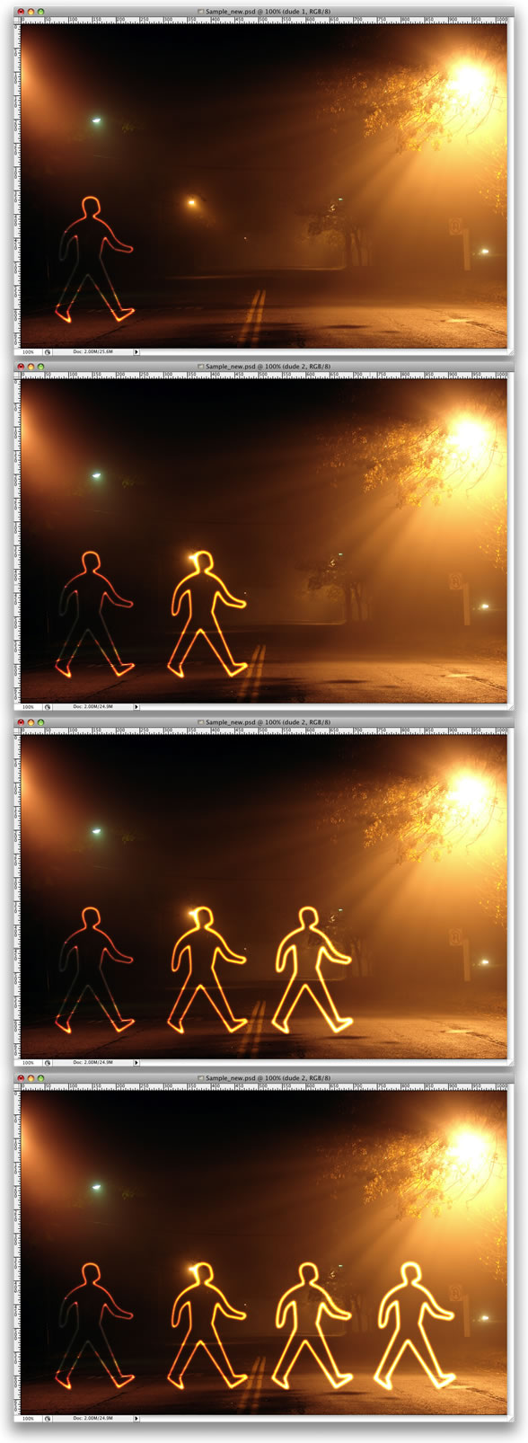

Step 8
Select the Rectangle Tool and create a rectangle. Then duplicate the rectangle several times. After that align and distribute them horizontally.
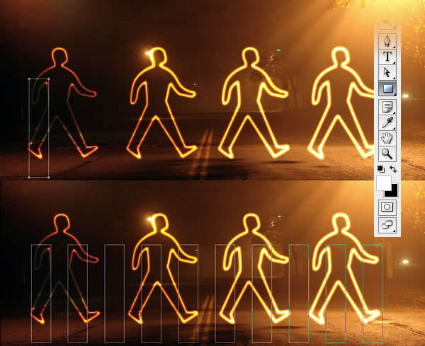

Step 9
Create a new layer inside the lights folder. Rename it to “xing”. Repeat Step 6 and Stroke the paths.
Within your Paths Palette – make sure the Work Path is NOT selected before you proceed.
Select the “xing” layer and go to Edit>Transform>Distort. Now just move the vertices until the perspective is good—just follow the street lines.

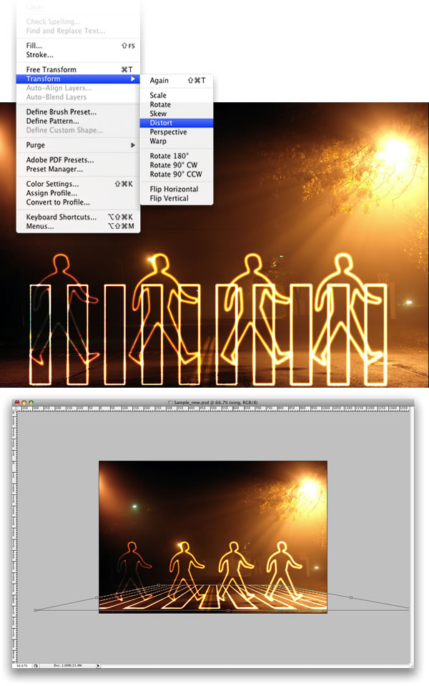

Conclusion
That’s probably the easiest way to create this type of light effect; however, it depends on the color of the background. Try changing your Layer Styles and Blending Modes to give your images more glow.
You can make the lights brighter by just duplicating the layers. You can even use the Eraser Tool(E) to make some adjustments.
