Fonts

Create an image made entirely of fonts. If you need to add additional images you may, but don’t let them take over your design.

The shape and appearance of a word can say as much as the word itself. That’s why it’s important to use fonts well.

- Be cautious of using more than three different fonts. This may result in your design appearing too cluttered. Good graphic design usually employs consistency and restraint in selecting appropriate fonts.

- The position of words should be imaginative, original, and purposeful.

- Look for fonts that mix well with the message or subject of your design. For example, serious communication requires a serious, authoritative look.

- A Serif font is a font with small “feet” on the letters. Times New Roman is a Serif font, and is well suited for body text, as the feet on the letters help your eyes to follow along the words.

- Almost all published books use Serif fonts, because it’s easier on the eyes. A Sans-Serif font like Arial does not have “feet” and is a good headline font because it’s big, bold, and calls out from a distance.
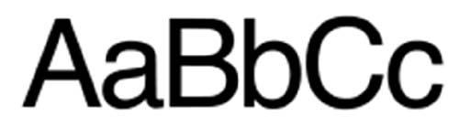

Objectives:

- Alter text through layer styles, warping techniques, and defining brush presets.
- Demonstrate attention to detail, selection, and opacity.
- Demonstrate attention to layout and composition.
- Arrange text by following contours within an image.

