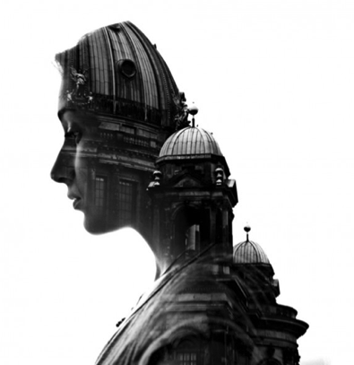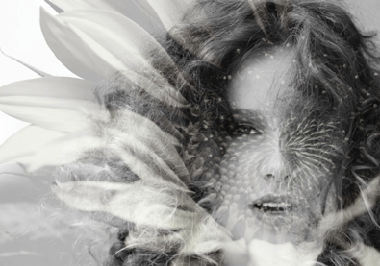

Double Exposure

- Place two images in Photoshop. The first image should be a portrait and the second should be a landscape, city scene, jungle, architecture, etc.

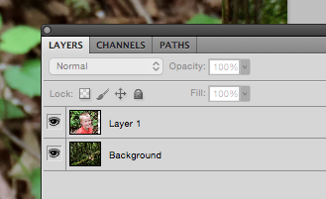

- Free Transform these images to fit in the document space. Also, Layer > Rasterize > Smart Object.

- LAYER 1 (your portrait layer) use a selection tool to select the background.

- Refine Edge to create a clean looking selection.
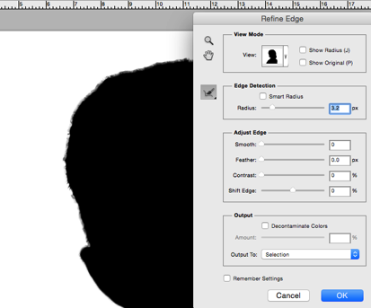

- Erase the background you selected with the Eraser Tool. KEEP THE SELECTION ACTIVE!!

- BACKGROUND LAYER (your landscape layer) erase the area around your portrait. Apply a gradient around the images. Command D to deactivate your selection.

- BOTH LAYERS use adjustments to increase contrast.

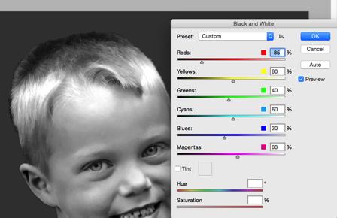

- Change the Blending Mode on LAYER 1 to OVERLAY.

- Use the Burn and Dodge Tools to add darker values and lighter values.

- Flatten Layer, save with your name, and change to JPEG. Drop Box

