Denis Gonchar
(Gone-char)

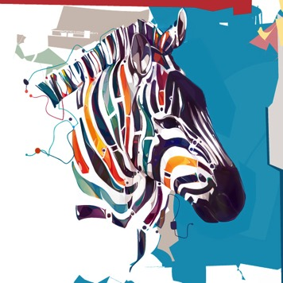

- New document (US Paper, color mode RGB)
- Open beetle image of your choice. Import image to New Document
- Create a New Layer and begin assembling your shapes.
  - Rectangle Tool
  - Rounded Rectangle Tool
  - Ellipse Tool
  - Polygon Tool
  - Line Tool
  - Custom Shape Tool
- In your Option Bar select “Fill Pixels” symbol.
- Select your Foreground color and use the eyedropper to obtain colors directly from your image.
- Duplicate shapes with Move Tool and Option key.
- Manipulate shapes with Edit > Free Transform or Edit > Transform
  - Scale
  - Rotate
  - Skew
  - Distort
  - Perspective
  - Warp
- Outline your shapes with Edit > Stroke.
- Add dimension to your final shapes altering Layer Styles > Bevel & Emboss.
- Don’t forget to create new layers. It will make it easier to remove shapes you decide to change. Also, merge layers together once you have 3 or 4 shapes exactly how you want them. This will minimize the total number of layers to keep track of. Shift to select layers, Layer > Merge Layers.
- Your final design should not include any portion of the original image.
- The background should include shapes and lines inspired by the artist.

