Cubism

Recreating an image by fracturing, rotating, and showing multiple viewpoints.

Alter Still Life 2 Ways:

- Use Rulers & Grid
View > Show > Grid
Photoshop > Preferences
Gridline every 1”
Subdivisions 1
Select with Marquee Tool, right click “Layer via Cut” or “Layer via Copy” and move each square around to create fracturing.

- Use Polygonal Lasso Tool and Patch Tool to alter pieces of the Still Life.

Part 1 - Still Life

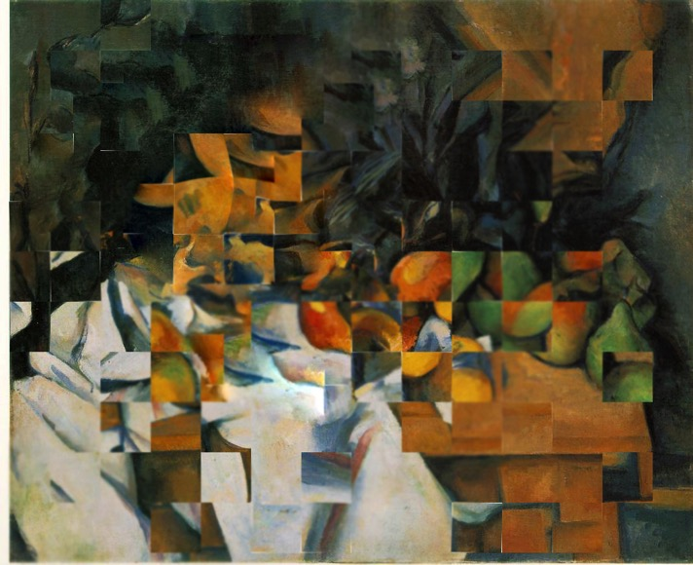

Part 2 – Your Choice

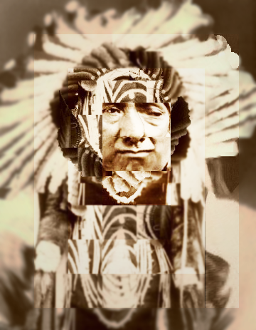

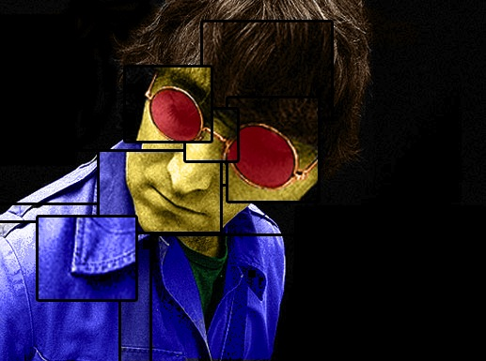

Alter your image through fracturing, changing color, utilizing filters, applying stroke, blur, smudge, dodge, burn, and patching.

