Create a Pseudo HDR Image

Step 1
You should start out with a high quality photo that has good lighting and obvious highlights. I chose the following photo because it has a lot of details I wanted to bring out in the face.
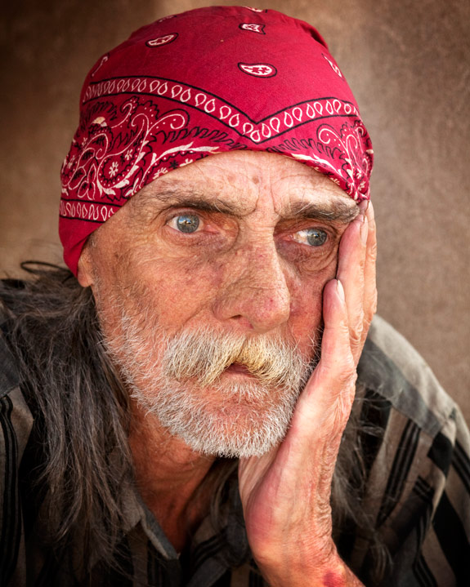

Step 2
Duplicate the Layer, then go Filter > Other > High Pass.
Set the Radius to 4.0 and then set the Blending Mode (In Layers Palette) to Vivid Light.
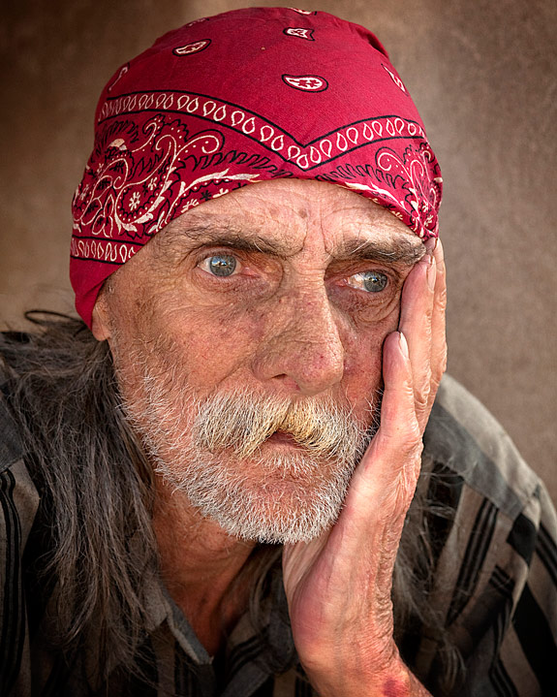

Step 3
Flatten the image, then duplicate the layer, go Filter > Other > High Pass.
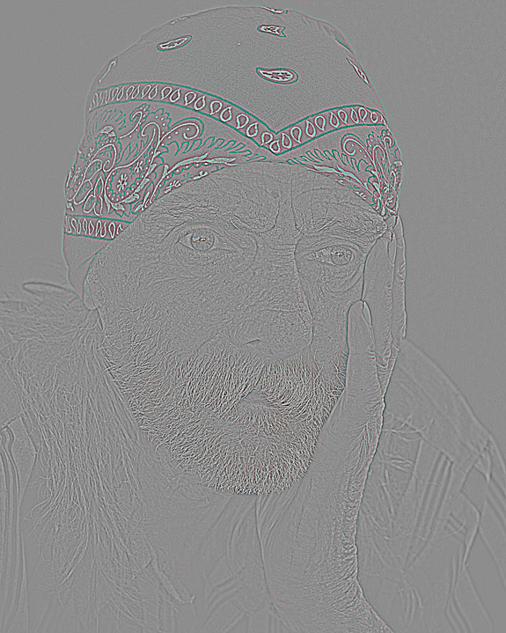
Set the Radius to 6.9 and then set the Blending Mode to Color and the Opacity to 40%
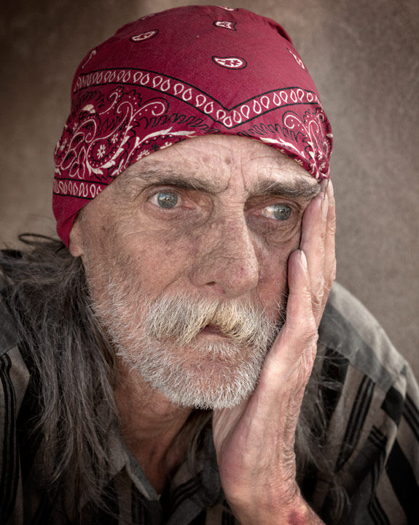

Step 4
Flatten the image, then duplicate the layer. Add a Gaussian Blur. Filter > Blur > Gaussian Blur. Set the pixels to 9.4
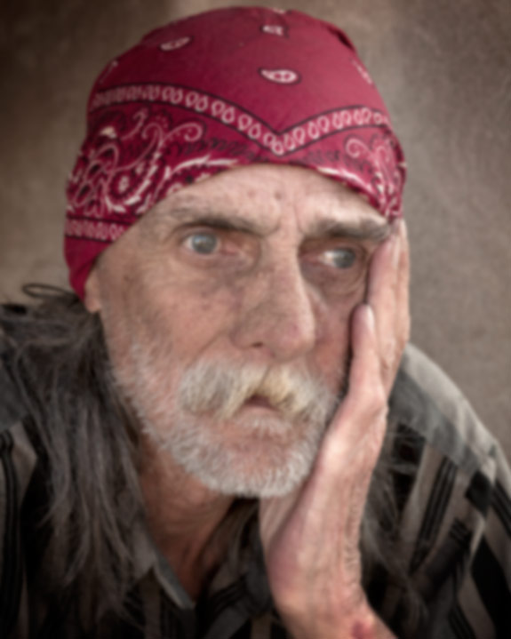

Step 5
Add some noise to the image. Filter > Noise > Add Noise, set the amount to 3%. Now add a mask to the layer. From the top menu, select Layer > Layer Mask > Hide All. Set the foreground color to white and background color to black, then use a soft brush at 30% opacity and start brushing over the entire image, except the eyes.
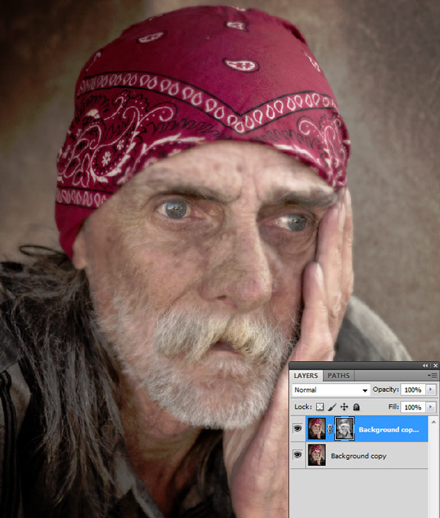
Step 6
Flatten the image again, then go Filter > Sharpen > Unsharp Mask and use the following settings.
Amount: 100%
Radius: 20.00 (This value may be different, depending on how much detail you need)
Threshold: 0
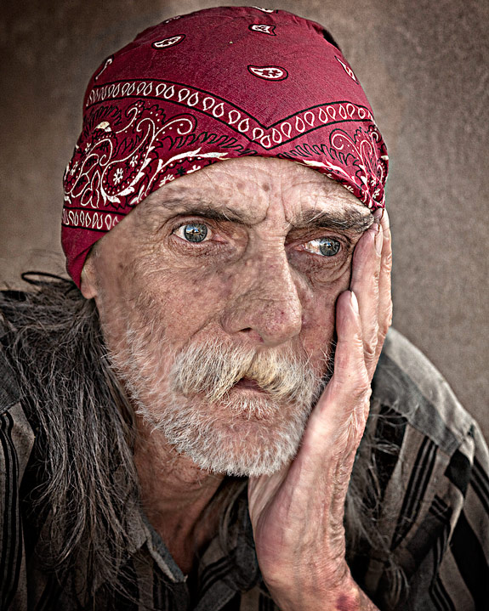

Step 7
Now add some curves to the image to bring out a little more details and highlights. Go Image > Adjustments > Curves.
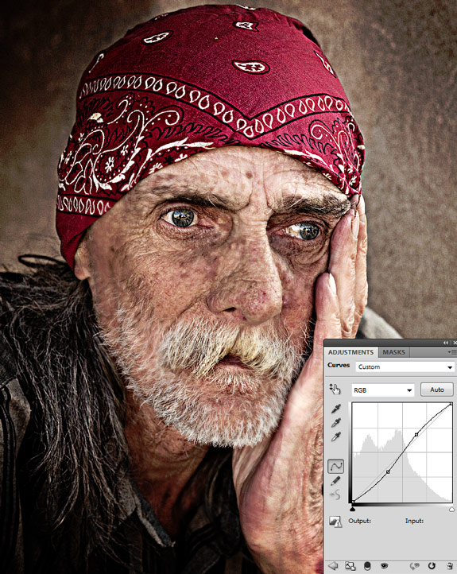

Step 8

Add a quote or song lyric that reflects the emotions of the image you selected.

Final Image
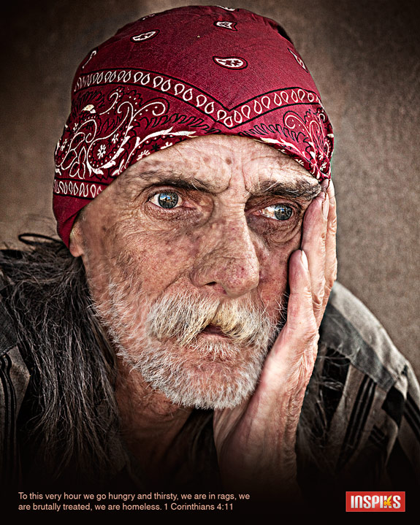

Conclusion:
This type of image processing is great for bringing out extra details in your images. The technique can be taken to extremes by playing around with the radius settings in the High Pass Filter, but it can also lead to ghosting and other unwanted artifacts. Play around with different images, you may find the effect useful in some of your projects and most of all, have fun!

