Animal Manipulation Tutorial
In this tutorial, we're going to combine 2 animals. 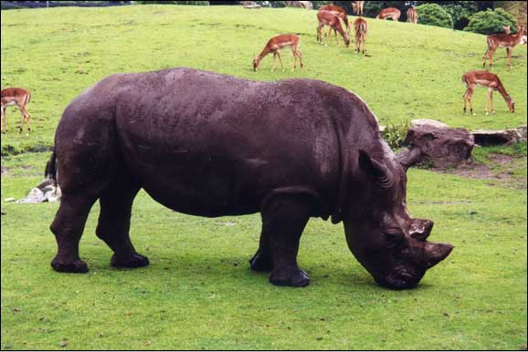
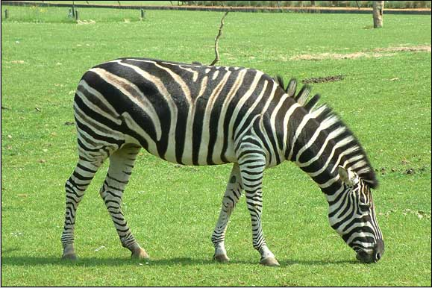
To make our final product below:
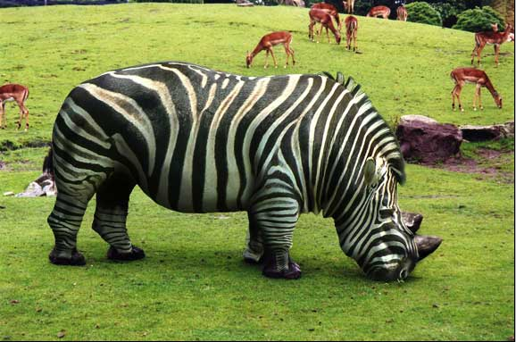
First and most important is to find the proper source images. I chose these 2 since the angles and stances are very similar. Copy and drag both images into the PS program.
Since I liked the high contrast color of the zebra, I decided to use the actual fur and "mold" it over the rhino's body. NOTE: It's a good idea to use a hi-res image because when you're stretching pixels, a low-resolution file is going to lose its realism.
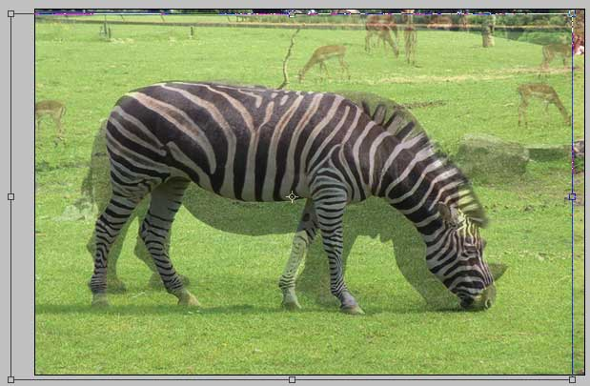
First, I extracted the zebra from its background and pasted it into the rhino file on a new layer.
I did this by selecting the Zebra, removing it from the background, and placing it on top of the Rhino. You may do this with Magnetic Lasso or Pen tool. It doesn’t need to be perfect, but it will be easier the closer to can get.
Okay, let's see how similar or different these two images are.
Lower the opacity of Zebra to 70% (in the layers palette) and compare it to the Rhino background. Using the Transform tool, stretch and compact the image as needed so that you could get the best fit possible. The better match now means less work later.
I found it important to match up the legs first and then the head for this image.
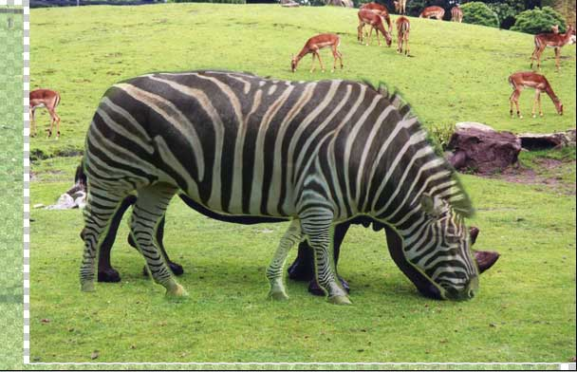
Since my goal is to cover the rhino's body completely with the zebra, I decided to use the Liquify filter to make the rest of the adjustments. This is located at the top of your screen, Filter > Liquify.
You need to have quite a bit of patience with the Liquify filter to get the best results.
1. You will need to go back and forth between regular screen and Liquify screen to see how it is lining up.
2. Start off by using a fairly large brush and with small strokes, pull the Zebra's main torso to match the rhino. Try to avoid making looong pulls because you won't get desired results. Using the large brush, I basically stretched out the top, buttocks, belly, chest and then I repositioned the head.
3. Once you're happy with those results, you're then going to fine tune the rest of the body using smaller sized brushes. For the Zebra's head, I used small, even strokes to match the shape of the underlying Rhino. Don’t forget to use Command button and + or - to zoom in and out quickly.
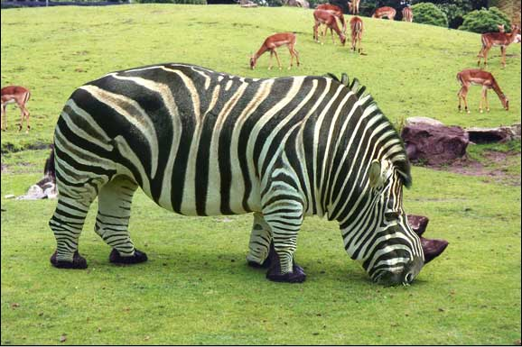
Okay, the shaping looks ok but our new animal friend is looking a bit flat. We're going to add more depth to this image by adding shadows. I'm not going to be using any blending modes because I want to keep as much detail and contrast as I can.
Make a new layer (Layer > New > Layer) atop the Zebra and select a soft brush and set a 30% opacity in your options bar.
TIP: In Layer Palette, hold down the OPTION key and move the cursor in between new blank layer and the Zebra layer. When the cursor changes it's shape, click the mouse button and you have now effectively made a clipping mask. All your shadows will now be contained inside the zebra.
Start shading in the edges of the zebra. Notice that the belly and two legs require a significant amount of shading. Alter your opacity and layer in those sections.
To get the best shading, I occasionally turned the visibility of the Zebra layer on and off used the Rhino background as a reference as to where to add new shadows.
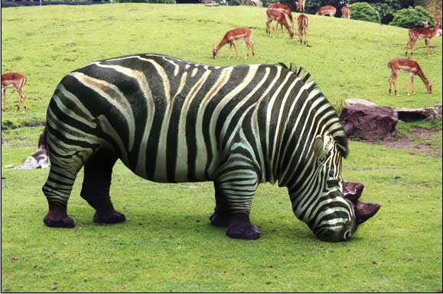
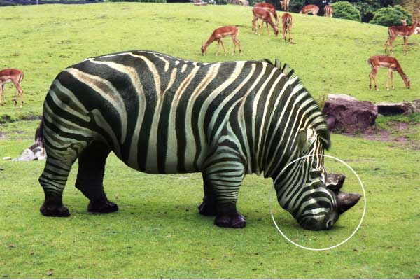
If you look at the original rhino picture, you'll see that the head has a distinct shape under the horns. It looks like its beefed up.
Okay, add a new layer
Using a smaller, soft brush at around 30% opacity, draw out the distinct lines under the horns (again, use the rhino background image as a reference). With some patience you should get the desired results.
If you find that the shading is a bit too dark, you could adjust the layer opacity of your shadows.

When you are finished, please save as “Your Name Animal” and drag to Drop Box.

