Color Wheel
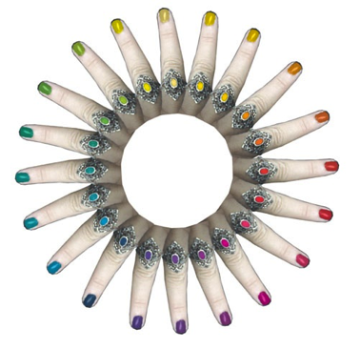

- Workspace & Resetting Essentials
- Windows
- Layers Palette
- New File
- Place Images
  - File > Open
  - File > Place
  - Drag
  - Duplicate Layer
- Zoom In & Out
- Arrange Document Window
- Selections
  - Marquee tools
  - Lasso tool
  - Polygonal Lasso tool
  - Magnetic Lasso tool
  - Quick Selection tool
  - Magic Wand tool
  - Inverting Selections
  - Refining Selections
  - Quick Mask mode
- Color Replacement tool
- Brush tool

