Chuck Close Portrait

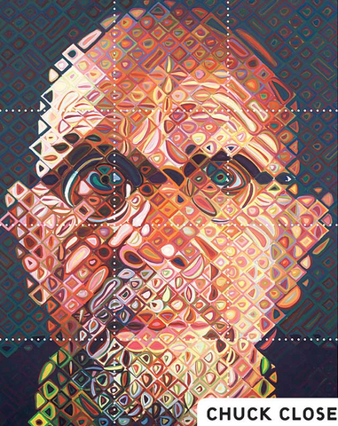

Create a portrait using the same grid method technique of Chuck Close. You will decide on orientation, shapes, colors, and technique.

Finished Project Requirements:

- Use an up close portrait as the basis for your design.
- Final image needs to be US Paper size (8 ½ X 11).
Image > Image Size
- Grid needs to be at least ½ inch in diameter.
View > Show > Grid
Photoshop > Preferences > Guides, Grid, & Slices.
- Demonstrates creativity and experimentation.
- Two files need to be submitted to the Drop Box. PSD & JPEG

Tool & Techniques:

- Square Brush (Brush Tool)
- Grid Selections (Fill)
- Image > Adjustments
- Mixer Brush
- Fill Layer (Eraser Tool)
- Blur & Smudge
- Opacity
- Duplicate (Move Tool)

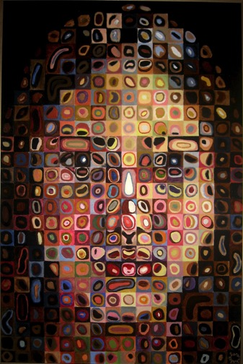
Student Sample

