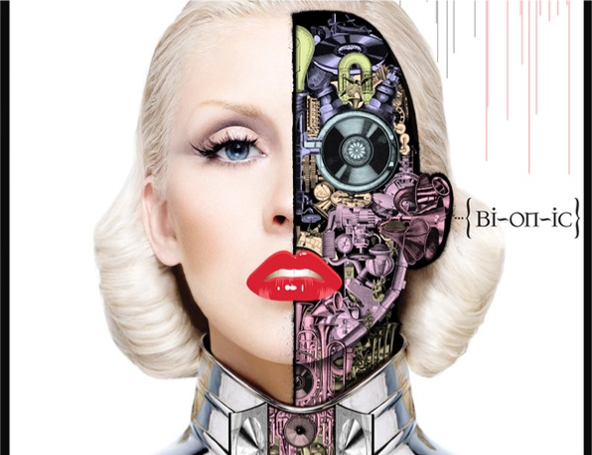

Album Cover

- Open Photoshop and alter your image using Adjustments, Filters, and Selection Tools. Save As > PNG to preserve transparency.
- File > Place image in Illustrator. [Adobe Illustrator > File > New] [Width 8 Inches & Height 8 Inches]
- Create Background, Text, and Shapes.
- Demonstrate balance and utilize design space.
- Final Design needs to be saved with AI format and placed in the Drop Box.

